΄Αδειες Χρήσης

- Το παρόν εκπαιδευτικό υλικό υπόκειται σε άδειες χρήσης Creative Commons.
- Για εκπαιδευτικό υλικό, όπως εικόνες, που υπόκειται σε άλλου τύπου άδειας χρήσης, η άδεια χρήσης αναφέρεται ρητώς.

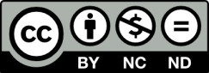

Χρηματοδότηση

- Το παρόν εκπαιδευτικό υλικό έχει αναπτυχθεί στα πλαίσια του εκπαιδευτικού έργου του διδάσκοντα.
- Το έργο «Ανοικτά Ακαδημαϊκά Μαθήματα στο Πανεπιστήμιο Αθηνών»
έχει χρηματοδοτήσει μόνο τη αναδιαμόρφωση του εκπαιδευτικού υλικού.

- Το έργο υλοποιείται στο πλαίσιο του Επιχειρησιακού Προγράμματος «Εκπαίδευση και Δια Βίου Μάθηση» και συγχρηματοδοτείται από την Ευρωπαϊκή ΄Ενωση (Ευρωπαϊκό Κοινωνικό Ταμείο) και από εθνικούς πόρους.

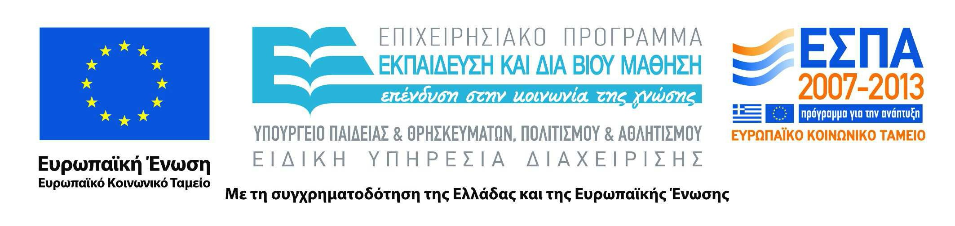

Codification
Codification is the process of bringing together a legislative act and all its amendments in a single new act. The new act passes through the full legislative process and replaces the acts being codified.
There are two types of codification:
- vertical: one original act and its amendments are incorporated in a single new act;
- horizontal: two or more original acts covering related subjects - and the amendments to them - are incorporated in a single new act.
Codification takes as its starting point the consolidated texts produced by the Publications Office. Those texts assemble the articles of an original act and the amendments in a single non-official document intended for use only as a documentation tool.
On the basis of that text a complete new act is prepared combining the original act and the successive amendments without any further substantive changes. That new act must pass through all the stages of the legislative process, although an accelerated procedure has been agreed by the European Parliament, the Council and the Commission.
The advantages of codification are that
- users need consult only one single authentic text, and
- the volume of the "acquis communautaire" (all the binding legal acts adopted by the European institutions) is reduced.
An example of a codified act based on a previously consolidated text is Directive 2006/12/EC of the European Parliament and of the Council of 5 April 2006 on waste.
By a Communication dated 21 November 2001 the Commission launched a project to codify the “acquis communautaire” in order to improve the accessibility of Community legislation. The project covered about 500 acts which had been amended one or more times and was managed by the Legal Service. The task was complicated by the multilingual nature of Community legislation, which led to the need for all texts to be translated into 9 new official languages from May 2004 and 3 further new languages from January 2007. The project was officially completed in 2009 and the results are set out in a list showing the detailed outcome of the planned codification acts.
The codification work now continues according to the existing needs on the basis of a yearly planning, included in the Commission's work programme.

