**These Are London’s Oldest Restaurants That Have Stood The Test Of Time**

While London's buzzing with [exciting new restaurants and bars](https://secretldn.com/new-restaurants-bars-london/) week on week, we mustn't forget about the iconic classic establishments that have stood the test of time.

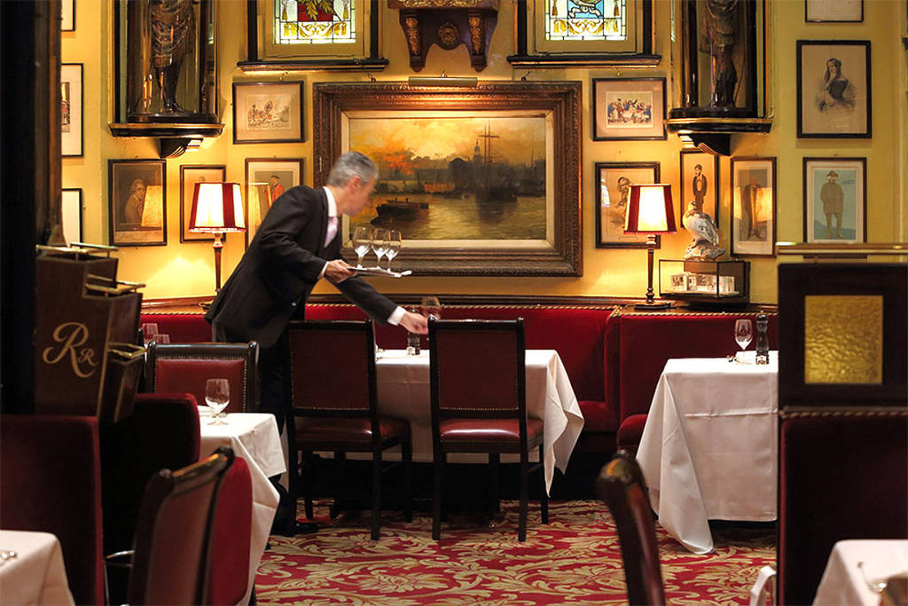Believe it or not, London’s history extends **over 2000 years** and so it comes with no surprise that some of the longest-standing eateries have been around for a **number of decades or even centuries.** But with new restaurants opening every week, it’s easy to forget about the golden oldies. From **hosting royalty to witnessing both the World Wars,** they have all sorts of stories and histories embedded in their walls and years on, still retain an excellent reputation for a wonderful dining experience.

**How we handpick the best of London’s oldest restaurants**

Each restaurant on this list has been carefully chosen by a member of our team. Our editors and the Secret London team rely on personal experiences, recommendations, editorial reviews, customer feedback, and thorough research to bring you the finest dining spots in the city. We are constantly on the lookout for new places with delicious food and excellent service. This list is regularly updated as we discover new openings and revisit established favourites.

So, we’ve put together a list of **London’s oldest restaurants that you must visit at least once**.

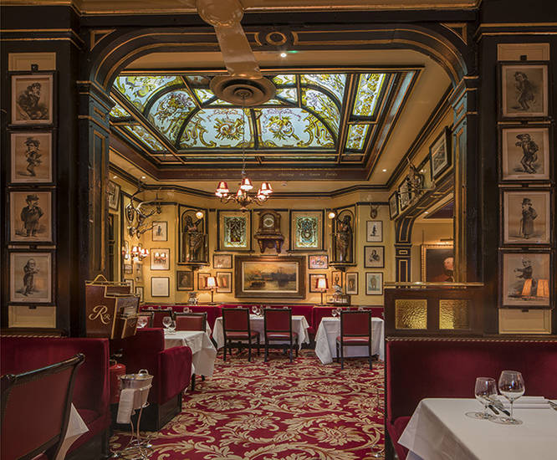**1.** [**Rules**](https://secretldn.com/oldest-restaurant-london-rules/)**,** [**Covent Garden**](https://secretldn.com/things-to-do-covent-garden/)

**Rules’** is regarded as **London’s oldest restaurant and longest-standing restaurant**, establishing itself in **1798**. Yep, you read that correctly. And so as you could imagine what the decor would be like – **interiors embellished in red and gold with tons of galleried areas with art** dated to back then, **velvety sofas, carpeted floors and beautiful ceiling details.**

It’s only then fair to expect **dishes like fresh oysters, game and pies** – **with most of its produce coming the restaurant’s very own estates**. While you’re there, **be sure to head to the upstairs bar and go for the recommendations.** You won’t be disappointed.

*35 Maiden Lane, Covent Garden, WC2E 7LB.*

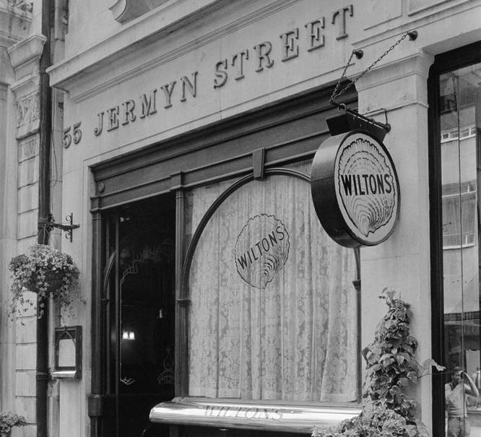**2. Wiltons,** [**St. James’**](https://secretldn.com/st-jamess-summer-itinerary/)

**Wilton’s is a restaurant so old, that it predates the formation of the United States.** Starting originally as an oyster stall in **1742** before finally finding a place in St James in the 1840s, **Wilton’s is one of the finest** [**seafood restaurants in London**](https://secretldn.com/seafood-restaurants-in-london/) complimented by a stunning rich history.

One of the best stories associated with its long history is probably the change of ownership back in World War II. Bessie Leal, the then-owner, was rattled after a bomb fell nearby and asked one of her diners, Olaf Hambro, if he knew anybody who wanted to buy a restaurant to which his response was “add the restaurant to the bill.” Pretty iconic. Other than that, it’s **‘no phones’ policy** makes it one of the most exclusive restaurants with **a three-course set menu available for under £40.**

*55 Jermyn Street, St. James’s, SW1Y 6LX.*

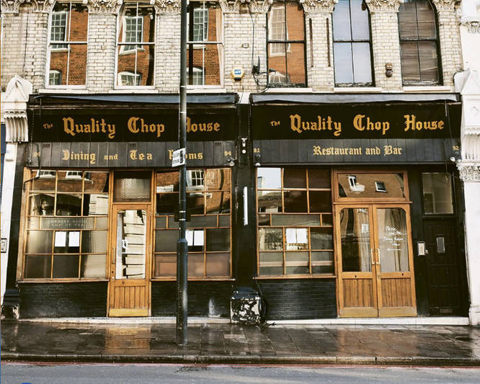**3. Quality Chop House,** [**Farringdon**](https://secretldn.com/things-to-do-in-farringdon/)

**Founded 1869**, the name and much of the interiors have remained the same but it’s important to note that it is probably the best it’s ever been now with **chef Shaun Searley’s** influence. While the restaurant has been through a variety of iterations, the **heritage-protected building is split in two with a dining room serving fresh daily set menus and a bar on the other side serving up a special list of wine.**

The menu aims to focus on **rare breeds and choice cuts**, which are **aged in house and selected daily** from their butcher shop next door. So if you’re a fan of [steak restaurants](https://secretldn.com/best-london-steak-restaurants/), this spot is for you.

They have a **weekday set menu available Tuesday to Friday at lunchtime for £29 for 3 courses**. They also have a **Sunday menu which is a set lunch at £55 for 3 courses**, which includes their [Sunday roasts.](https://secretldn.com/best-london-roast-dinners/)

*92–94 Farringdon Road, EC1R 3EA*

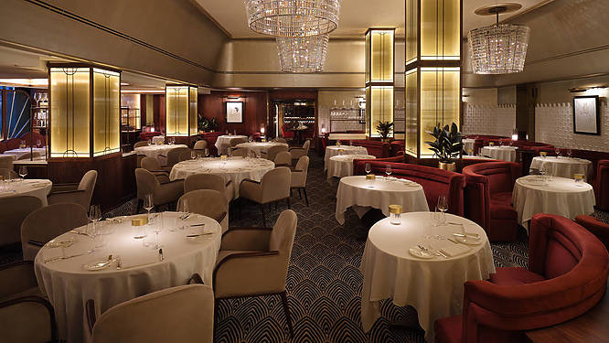**4. The Savoy Grill, Strand**

**The Savoy Grill** has been there since the hotel opening **in the late 19th century**. By 1904, the Grill became **one of the** [**best pre and post-theatre spots**](https://secretldn.com/best-pre-theatre-dinner-london/), **a favourite of Sir Winston Churchill, Charlie Chaplin, Judy Garlad, Errol Flynn, Elizabeth Taylor and more recently, the Beckhams.**

For a period of time, the Grill always felt like a gentlemen’s club (even though women were technically allowed) serving up classic meat dishes as opposed to fancy [French food](https://secretldn.com/french-restaurants-london/). With the smell of smoke, strong spirits and billiards rooms all around – it attracted the likes of men who wanted to conduct business or simply escape the frills of society.

**For the past 20 years, it’s been run by Gordon Ramsay.** Diners can still enjoy the f**amous classic dishes but with sophisticated and modern touches.** With similar items from its menu in 1914 such as **the Lobster Salade, Pâté de Foie Gras and Filet de Sole featured to today’s Duck Liver Torchon and Dover Sole dishes.**

*The Savoy Hotel, Strand, WC2R 0EU.*

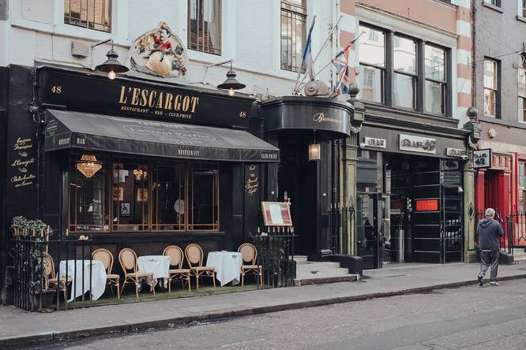**5.** [**L’Escargot**](https://secretldn.com/lescargot-restaurant-london/)**,** [**Soho**](https://secretldn.com/things-to-do-soho/)

Credit: Alena Veasey, Shutterstock

**L’Escargot** has been serving up its signature delicacy to hungry Londoners for over **100 years**. Way back in 1986, a guy named **Georges Gaudin** opened up a French restaurant in **Soho**, and originally called it Le Bienvenue. It quickly became an extremely popular spot, as it was (supposedly) the first place in England to serve up a certain French delicacy. That delicacy – of course – was **snails**.

Part of the Soho furniture, this French bistro has seen the likes of **Princess Diana, Coco Chanel, Mick Jagger and Elton John** cross its threshold. A trailblazer for London’s fine-dining scene; L’Escargot is everything you’d want and expect from a **fancy French restaurant**.

*48 Greek Street, W1D 4EF.*

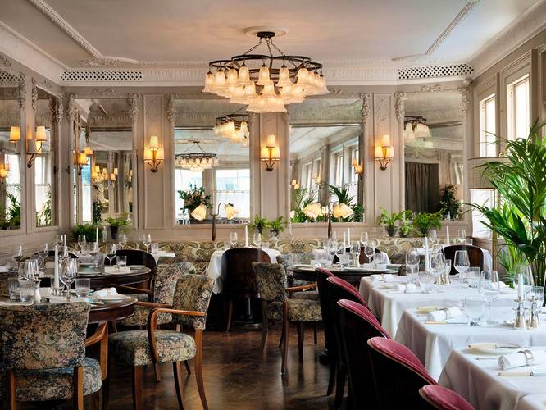**6. Kettner’s Townhouse,** [**Soho**](https://secretldn.com/things-to-do-soho/)

Credit: Kettner Townhouse

Soho House regulars might not know this, but **Kettner’s Townhouse was one of the first French restaurants in London**. Dating back to **1867,** it has played host to everyone from **Oscar Wilde to Winston Churchill.**

In 2016, its traditional **French food was swapped out for** [**British dishes**](https://secretldn.com/londoners-reveal-the-best-british-restaurants/) **with a Mediterranean influence** after the institution was bought by Soho House. While it began as a member’s club, the restaurant is now open to the public.

*29 Romilly Street, W1D 5AL.*

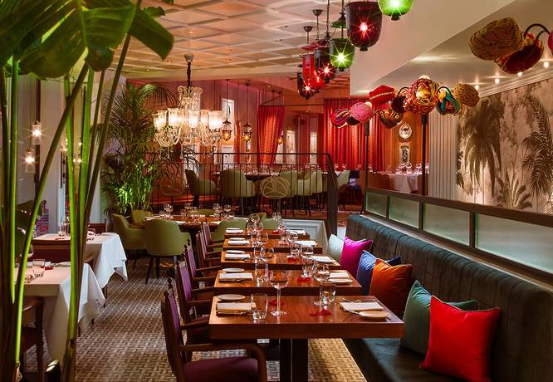**7. Veeraswamy, Regent Street**

**Opening in 1926**, it is indeed t**he oldest surviving** [**Indian restaurant**](https://secretldn.com/best-indian-restaurants-london/) **in the UK**. Veeraswamy was established by **Edward Palmer**, a retired British Indian Army officer, was the great grandson of **General William Palmer (Military & Pvt secretary to Warren Hastings – The 1st Governor General of India)** and an **Indian Mughal Princess Faisan Nissa Begum.**

Palmer was heavily influenced by his great-grandmother in the making of the menu, giving ode to her by taking her family name ‘Veeraswamy.’ They also **received a Michelin star** in 2016, which they still hold to this day.

*Victory House, 99-101 Regent Street, W1B 4RS.*

**8. The Ritz Restaurant,** [**St. James’**](https://secretldn.com/st-jamess-summer-itinerary/)

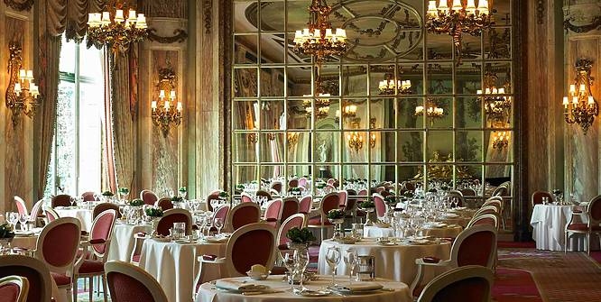Credit: The Ritz

**The Ritz** first opened in **1906 by César Ritz** and quickly established itself as being one of the most iconic parts of London and its hospitality scene. First, gaining patronage from **King Edward VII** followed by **Queen Elizabeth** often dining at the restaurant, and **The Queen Mother** apparently having a favourite table – history is embellished in the walls of the Ritz.

The entirety of the hotel was designed by London and Paris based designers in the **‘Louis XVI style.’** It’s been said that the great suit of ground-floor rooms is considered to be ‘**one of the all-time masterpieces of hotel architecture’** comparing it to the likes of a royal palace.

Over a 100 years later, in 2016, The Ritz Restaurant was **awarded a Michelin star** as well and till today, it’s considered one of the best dining experiences in the world and definitely one of the [prettiest restaurants in London](https://secretldn.com/prettiest-restaurants-london/).

*150 Piccadilly, St. James’s, W1J 9BR.*

**Πηγή:** <https://secretldn.com/oldest-restaurants-london/>