Labour peer apologises for suggesting asylum seekers should be 'concentrated' in camps
Admiral Lord West was a Home Office minister under the last Labour government
Jon Stone, Policy Correspondent | Sunday 11 October 2020

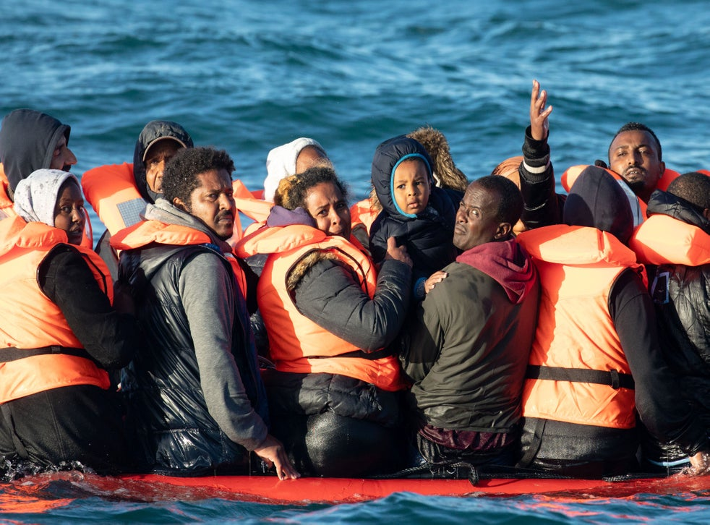
People crossing the English channel on an inflatable boat near Dover (Getty Images)

A Labour peer has apologised for suggesting that asylum seekers should be "concentrated" in camps as a solution to the refugee issue
Admiral Lord West, who was a Home Office minister under the last Labour government, made the "inhumane" suggestion in an interview with the BBC.
Speaking on Sunday morning he said people arriving across the Channel in small boats should be put in "a concentrated place, whether it's a camp or whatever".
The comments prompted outrage, with Liberal Democrat home affairs spokesperson Alistair Carmichael telling The Independent that the peer should instead be joining "calls for safe and legal routes to sanctuary for refugees".
Mr Carmichael added that the comments were a good demonstration of "why being a retired Admiral is not, in itself, a basis on which someone should be appointed to take a seat in parliament".
The Labour peer had suggested that the "concentrated" camp might be a good place to hold migrants and asylum seekers until the UK could secure "agreement from France and other European nations to take them back.
Approached about the comments, Lord West said: “I am sorry for my choice of words and the confusion caused. I was trying to get across the point that working with other EU nations will help resolve this.”
Commenting on the incident, a Labour Party spokesperson said: “The Labour Party is clear that all people should be treated with humanity, compassion and respect.”

Πηγή: https://www.independent.co.uk/news/uk/politics/labour-peer-concentration-camps-asylum-seekers-immigrants-admiral-lord-west-b966337.html

Μεταφραστικές οδηγίες
Η μετάφραση θεωρούμε ότι θα δημοσιευτεί στην ιστοσελίδα μιας καθημερινής εφημερίδας την επομένη της δημοσίευσης του πρωτοτύπου.
Στις μεταφράσεις δεν χρειάζεται να περιλάβετε τη φωτογραφία του πρωτοτύπου.

