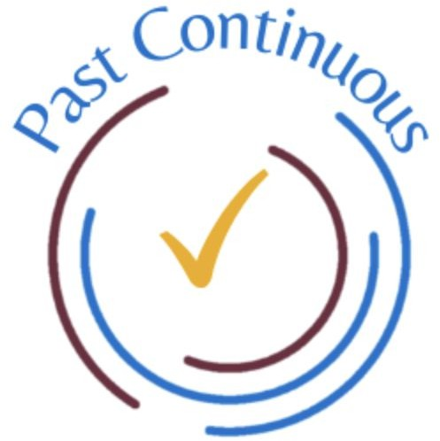

Media Literacy and Propaganda

Greece
Propaganda in the Metaxa’s Juncta (1936-1941)

DESIGN OF THE E-LEARNING, AIMED AT STUDENTS AND THE TOOLKIT AIMED AT TEACHERS

Proposal for Erasmus+/ Introduction to e-learning

Education is a coherent pillar of a wider social context and public education is always part of a social project to promote
the next generation. The humanities are expanding interdisciplinarily, integrating new ways of perceiving and interpreting their data, with the science of history playing a role, more crucial than ever before, in managing and answering novel questions. The European Union oriented by the compass of the transition to a technologically and environmentally informed human potential, which understands the importance of adaptability and respect for the environmental needs of nature and its functions, is adopting changes that in digital culture are identified as “digital humanities” (Schreibman S. et al., 2016: xvii). And pedagogical practices have to adapt intelligently, taking advantage of the latest trends in education, especially those that act additively on children's learning (Daniela, 2020). The Council of Europe (2018) report “Principles and Guideliness for a Quality history education in the 21st Century-Principles and Guideliness” (n.d.) and The Reference Framework of Competences for Democratic Culture (RFCDC) identify the Council's values regarding human rights, democracy and equality. They are oriented towards the creation of a corpus of texts that reinforce the character of history education within the core of the Member States of the Eurozone countries, with the aim of cultivating historical literacy,
structured around the components of historical thinking, historical understanding, critical thinking and empathy, with a view to strengthening democratic culture and intercultural dialogue in order to ensure transparency and consistency.
In a democratic society, the function of history is that “by recognizing the importance of consequences, events, coincidences and other human developments, in every human enterprise, position and institution... it opens up new possibilities for action and ways of seeing things” (Lee, 1984b:12). Seixas (2018) approached the changes that threaten liberal democracy at the global level, emphasizing the importance of history education in preventing and addressing them, advocating a multifaceted history curriculum that aims to address the fragmented attitudes and manifestations that appear in the public sphere of contemporary societies (Seixas, 2018: xv) arguing that teaching must give students space to discover and interpret, while allowing them to learn to respect evidence and the limits of interpretation: and there for Seixas the central challenge rests: in formulating appropriate methods to help students understand the limits of interpretation, the constraints that link what we say to the evidence we have, and the importance of defending interpretations supported by the weight of evidence, not as one of many possible ways of seeing things.

Below, a model of the work to be developed in these two WP3 products or materials that will be contained in the same digital platform, with the intention of being more operational, agile, easy to apply in any other school context, which produce immediate feedback on the work done by students online from their teachers. Also, it can be established to make an evaluation by the teachers of this didactic instrument, apart from the evaluation of the students to verify their learning. To do this, it is necessary to indicate both in the toolikit, but also in the e-Learning the objectives and competencies of this learning tool.

Therefore, the big difference with respect to what was indicated at first, e-learning is a teaching and learning tool (and not only teaching); and the toolkit is an instrument for the use of the didactic material (and not just a theoretical foundation). In other words, everything becomes very practical.

Activity 1: An introduction to dissinformation
An introductory video or text in which a problem is contextualized: disinformation and fake news and in which it is commented that it has always existed. Two or three examples of historical fake news can be given, such as Constantino's Donation of the Edict of Fence in Antiquity.
Here are some examples: https://www.youtube.com/watch?v=27U
CF5id0DI

General assumptions of teaching scenario

Teachers will be asked to:
1. organize the educational process based on specific key concepts: historical significance, historical evidence, continuity and change, causality, historical perspective, moral and value framework, national identity, historical consciousness, historical thinking, democratic consciousness;
2. to structure it on the basis of specific teaching principles, organised along two axes:
⮚ The first axis concerns the historiographical assumptions related to the
content, structure and organisation of the historical material deemed necessary to constitute a common educational good, and
⮚ The second axis concerns the epistemological specificity, social role and teaching methodology of history and is related to the cultivation of historical thinking.

General Historiographical Assumptions:
1. Students should understand the journey of human societies through time not as a linear progression towards progress, but as a process of testing and adaptation.
2. to highlight the depth, breadth and diversity of human history and
experience, and the contribution of all past societies and cultures to the present.
3. To familiarize students with the multifaceted historical, archaeological, cultural and artistic heritage of Greece, as it was shaped by the synergy and interaction of indigenous elements, foreign domination, population movements and cultural loans, antiquities and transport.
4. To understand how the modern physiognomy of Greek society was shaped and to cultivate national consciousness alongside the consciousness of
democratic citizenship.

Teaching Scenario: Propaganda during the Metaxas Dictatorship (1936-1941)

Class: High school (in our case the choice of class is at the disposal of the teachers who will implement the approach in the school context).
Lesson: History
Subject: Propaganda in the Metaxas dictatorship and the techniques of manipulation of public opinion

General objectives:
As identified under the History Curriculum 2018 (n.d.).

Particular Purposes:
Historical Analysis: Students will study the circumstances leading up to Metaxas' dictatorship and analyze the political and social context of the time.
Understanding the Concept of Propaganda : Students will understand the concept and techniques of propaganda, and then approach the applications chosen by Metaxas' dictatorship.
Understand the techniques of Propaganda: Have students approach textual genres to identify expressive variation and verbal patterns, analyzing political discourse, recognizing how language, history, and ideology are used (or misused) in manipulating the masses.
Analysis of Historical Examples: have students analyse the above tools used by the regime to control information and cultivate state ideology.
Analysis of Ideological Directions.
Comparative Consideration: students should compare Metaxas' dictatorship with other totalitarian regimes in Europe (e.g. fascism, Nazism) and take a comparative approach to their techniques, identifying points of intersection or differentiation.
Critical Thinking: to develop critical thinking about the way propaganda affects society and compare it with similar contemporary practices.
Examination of Consequences: Have students discuss the consequences of the dictatorship on the political and social fabric of Greece, and the relationship of the regime to World War I

Prerequisite knowledge:
● Understanding of the terms of historical thought and consciousness and how they function in understanding history and their formative dynamics in interpreting it.
● Good knowledge of persuasive techniques (interdisciplinary with the Language course), source approach and documentary analysis.
● Basic knowledge of the historical context, the political situation in Greece before and during the inter-war period.
● Introductory knowledge of the Metaxas dictatorship (historical and socio-political context of the period).

Intended learning outcomes (common to all scenarios):
● To make students critical readers of different textual genres in order to understand and identify the basic techniques of propaganda, to develop critical thinking towards information so that they can distinguish manipulative messages.
● To make students understand the importance that totalitarian regimes (and not only) attached to the use of language and history as a legitimizing factor in manipulating the minds of the masses.
● To realize that the above abuses constitute a timeless phenomenon of indirect (or sometimes direct) imposition of the action of groups (political, religious, social) and legitimization of their theory through the instrumentalization of the historical past and by referring to social feeling (appeal to fear, reason, morality, etc.).
● Be able to situate themselves in time by understanding the dynamics of historical conditions and contexts (social, economic, political) in terms of enhancing the potential for the penetration of propaganda practices.
● Develop critical thinking in relation to information.
● Formulate arguments about the impact of propaganda on society.

Teaching application structure:

Teaching Hour( Based on the material presented in class and listed below):
Α. A. Diagnostic discussion/identification of students' prior knowledge (10 minutes)

1. Introduction to terms-conceptualization (fascism, Nazism propaganda. Teacher refers to the pages:
a. Fascism:
i. Dictionary of Common Greek: https://www.greek-language.gr/greekLang/modern_greek/tools/lexica/triantafyllides/search.html?lq=%CF%86%CE%B1%CF%83%CE%B9%CF%83%CE%BC%CF%8C%CF%82&dq=
ii. Encyclopedia Britannica: https://www.britannica.com/question/Where-does-the-word-fascism-come-from
b. Nazism:
i. Dictionary of Common Greek: https://www.greek-language.gr/greekLang/modern_greek/tools/lexica/triantafyllides/search.html?lq=%CE%BD%CE%B1%CE%B6%CE%B9%CF%83%CE%BC%CF%8C%CF%82&dq=
ii. Britannica Encyclopedia: https://www.britannica.com/event/Nazism

c. Propaganda:
i. Dictionary of Common Greek: https://www.greek-language.gr/greekLang/modern_greek/tools/lexica/triantafyllides/search.html?lq=%CF%80%CF%81%CE%BF%CF%80%CE%B1%CE%B3%CE%AC%CE%BD%CE%B4%CE%B1+&dq=
ii. Brittany Encyclopedia: https://www.britannica.com/topic/propaganda
2. Historical review: Presentation of the definition of propaganda and its various forms (political, social, war-white, black, grey).
3. Discussion on the importance of propaganda in totalitarian regimes and the techniques of its dissemination. Examples with basic techniques of media control, censorship, use of symbols, cultivating the mentality of Metaxas as “Father of the Nation”. Approaching the action of the National Youth Organization (NON) as a means of organizing, controlling and catechizing youth. Watching the posting: working battalions and EON: https://www.youtube.com/watch?v=DQS6BfDxkAs From:14:39 to 17:48 and comparison with the video https://www.youtube.com/watch?v=5HG3OmMXnoQ&list=PLRV12H386MjVChVXxKGLEKS7VZZ5c64a_&index=110

Classroom activity (15 minutes)
Students watch with the teacher clips from propaganda materials of the period (e.g. posters, texts, testimonies, audiovisual material from speeches by Metaxas and supporters of the regime) and discuss their first impressions.

Indicative classroom questions (15 minutes)
● Why do you think this magazine was published? (teacher refers to the digital repository webpage and browses through the publications and discusses with students the type of journal, its subject matter, how it began and how it developed.)
● From the available texts, can you identify places where a different ideology is targeted?
● How does the regime and its action appear? Can you identify examples from the texts?
● How Metaxas used propaganda to create a positive image of the regime and justify the dictatorship.
● How does Mrs. Fragia's testimony convey her personal experience? Do you think she still holds the same view?
● Studying the children's testimonies and looking at the corresponding photos, what are your feelings? Keeping Mrs. Fragia's testimony in mind, can you share your thoughts with the class?
● Examples of the use of propaganda to reinforce nationalist and anti-communist discourse (textual, visual).

Activity at home and its presentation to the class: With the teacher's guidance, students are divided into groups, each of which will approach a different piece of evidence (e.g. article, poster, radio extract) for analysis according to the methodology that was exemplified in class. Material to be approached and guidelines are given, where these were developed with the examples. In the next lesson, students will present to the class the techniques they identify and the message they believe the transmitter is trying to convey.
Propaganda techniques of the Metaxas regime and comparative analysis with other regimes or periods of Modern Greek history.

2nd Teaching Hour: Propaganda techniques of the Metaxas regime and comparative analysis with other regimes or periods of Modern Greek history.

Presentation of the work done in the groups and its development in class (10 minutes) (Examples)
1. Mussolini's Italy:
● Projection of Mussolini as a “douche” (leader) and savior of the nation.
● Use of radio, films and posters to promote fascist ideology.
● Use of the Latin term fasce to support his ideology which emphasized the concept of Roman greatness and national unity.
● Publication of a book (Musolini, B., “Fascismo” in Enciclopedia Italiana, vol.14th, pp. 847-884, 1932) with his positions.

2. Hitler's Germany:
● Projection of Hitler as “Führer” and messiah of the German people.
● Use of strong anti-Semitic propaganda and promotion of the Aryan race.
● Exploitation of the media under Joseph Goebbels to orchestrate propaganda.
● Staged targeting of the Jewish element through children's and family games.
● Publication of a book (Hitler, Ad. Mein Kampf ,1925) with his positions.
Starting from the last but common point, the publications of their political positions, we place the publications in historical time by approaching the historical context and especially the historical importance of the medium (book) in reaching the masses. It is worth noting that Mussolini's original text was written in 1927 (important chronologically) with the assistance of Giovanni Gentille, an idealist philosopher (where it can be approached as a legitimization of the ideology of the fascist phenomenon)
Class discussion of commonalities with Metaxas propaganda and comparison of techniques:

● Invoking the glorious past
● Appeal to emotion (fear, hope, anger).
● Use of stereotypes and pseudo-scientific arguments.
● Personalisation of the leader as a divine or heroic figure.
● Forms of dissemination and support of the ideology.

Suggested Material:

Mussolini:
https://www.youtube.com/watch?v=yIZ-Myd2i5o
Emphasis from 4:03 showing his speeches from cities in Italy.

Watching a brief historical retrospective regarding Hitler's rise to power (From 0:00 to 1:03. https://www.youtube.com/watch?v=jSwQN_0KWAY . excerpt that gives us images and ideally frames (in my opinion) the period we will be examining as it also shows elements of propaganda (teary eyes, historical context, parade images).

History Channel:
Historical context of Hitler's rise: https://www.youtube.com/watch?v=yEk6zGYwyhc
Hitler as leader. https://www.youtube.com/watch?v=6XnsYZxH2nI

Materials to be approached:

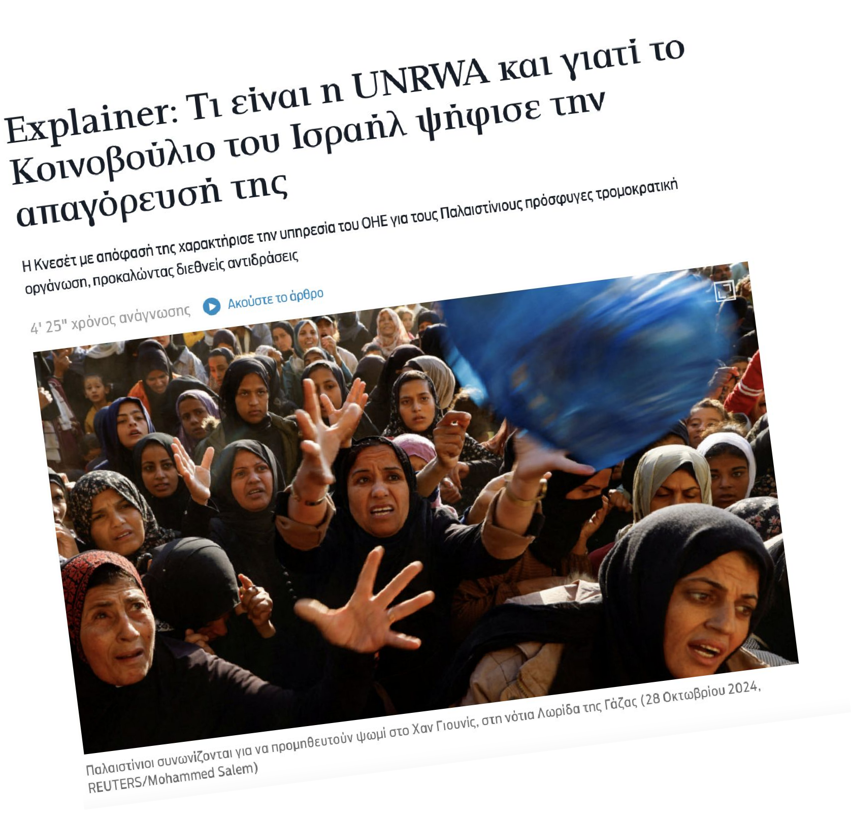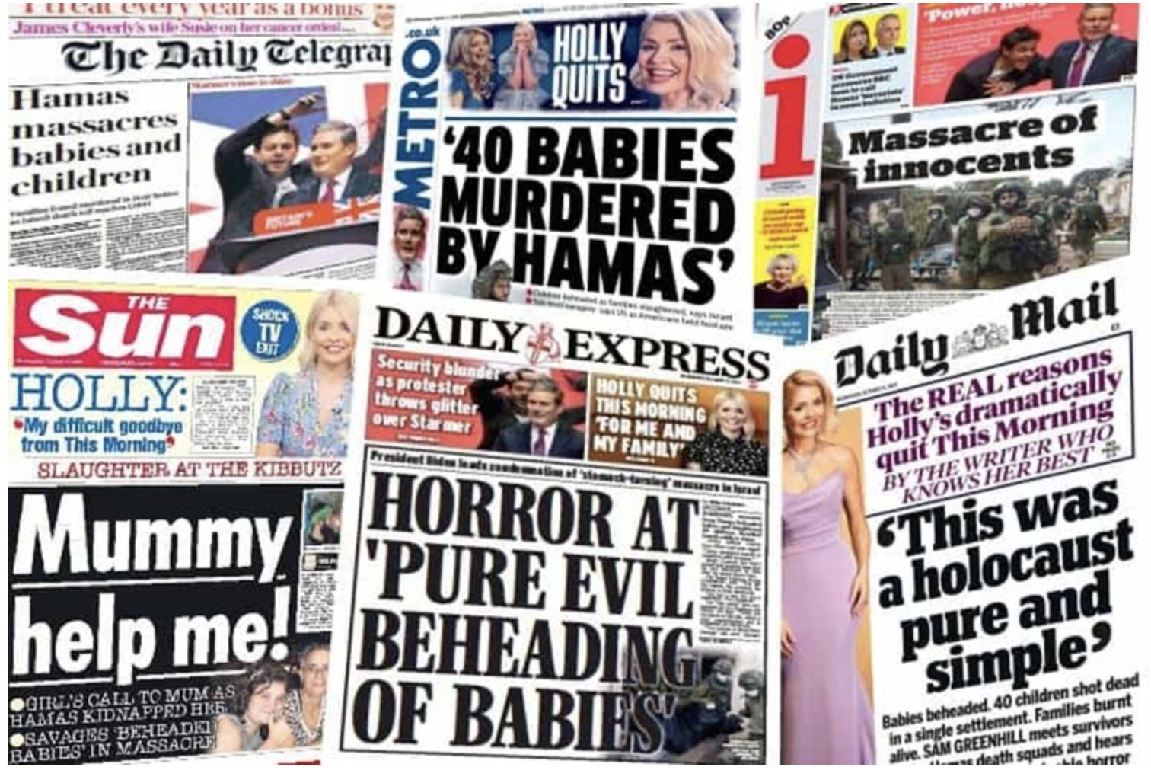

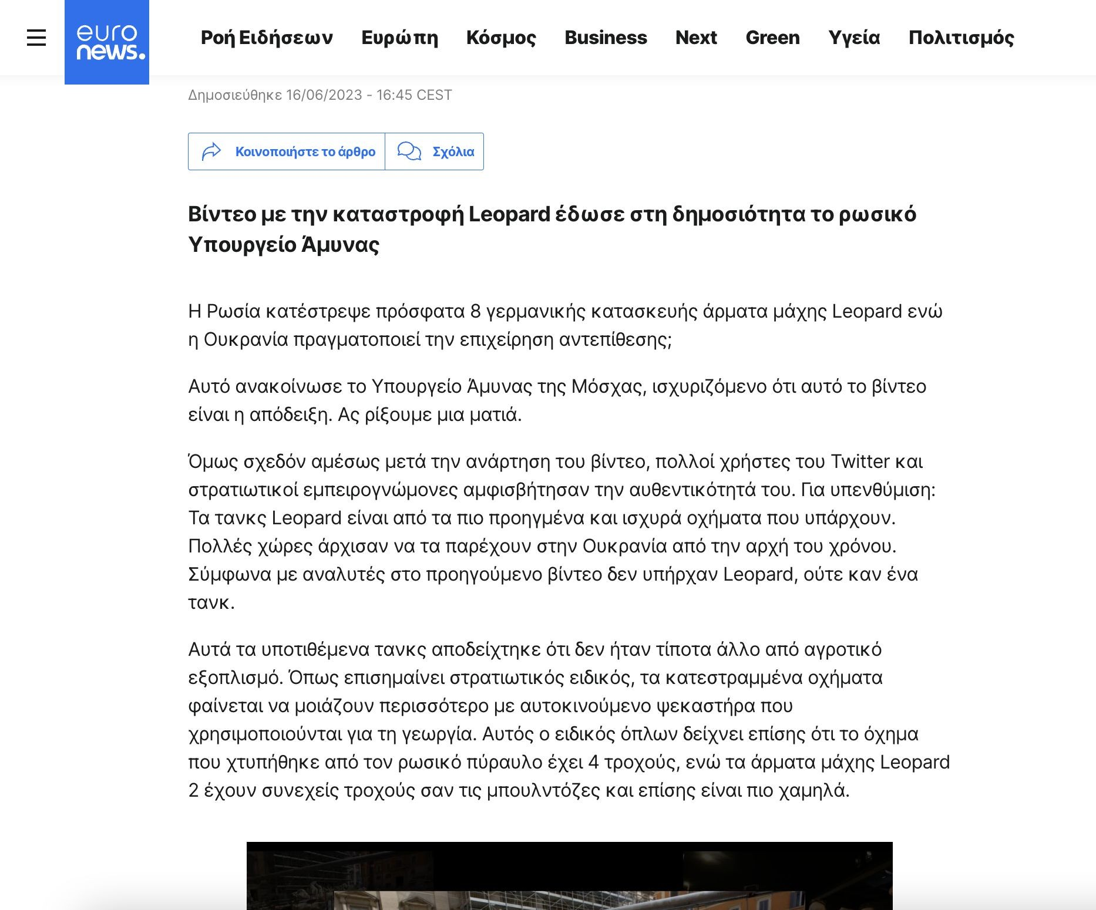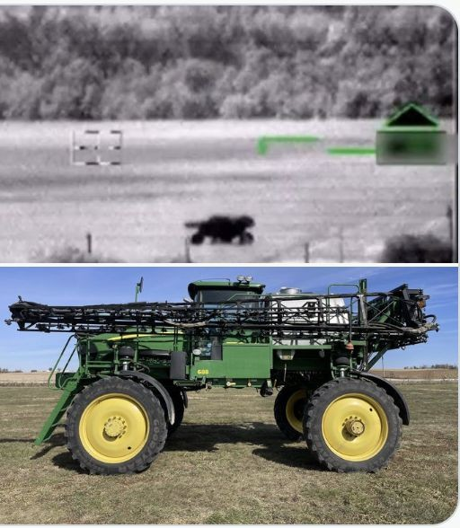

Ορισμός
propaganda, dissemination of information—facts, arguments, rumours, half-truths, or lies—to influence public opinion. It is often conveyed through mass media.
Propaganda is the more or less systematic effort to manipulate other people’s beliefs, attitudes, or actions by means of symbols (words, gestures, banners, monuments, music, clothing, insignia, hairstyles, designs on coins and postage stamps, and so forth). Deliberateness and a relatively heavy emphasis on manipulation distinguish propaganda from casual conversation or the free and easy exchange of ideas. Propagandists have a specified goal or set of goals. To achieve these, they deliberately select facts, arguments, and displays of symbols and present them in ways they think will have the most effect. To maximize effect, they may omit or distort pertinent facts or simply lie, and they may try to divert the attention of the reactors (the people they are trying to sway) from everything but their own propaganda.
Source: https://www.britannica.com/topic/propaganda Understanding propaganda and dissinformation:
https://www.europarl.europa.eu/RegData/etudes/ATAG/2015/571332/EPRS_ATA(2015)571332_EN.pdf

Δικτατορία Μεταξά

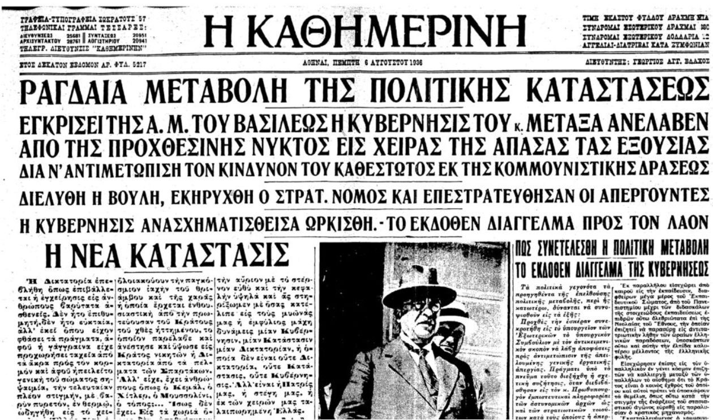

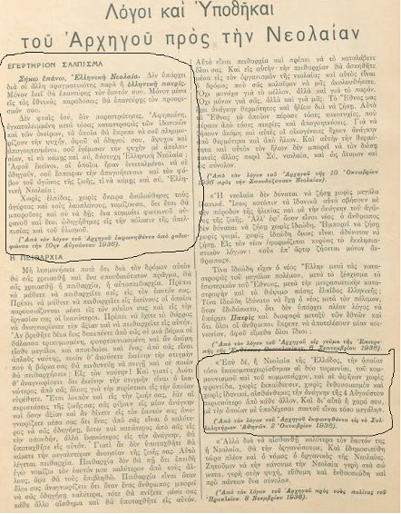
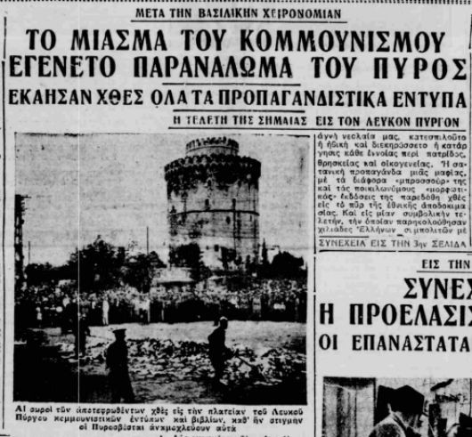

«Σας απαγορεύω να έχετε διαφορετικές ιδέες από αυτές του Κράτους. Σας ζητώ όχι μόνο να έχετε τις ίδιες ιδέες, αλλά να πιστεύετε σ’ αυτές και να δουλεύετε γι’ αυτές με ενθουσιασμό. Αν κάποιος από σας έχει διαφορετικές ιδέες, καλύτερα να μείνει αμόρφωτος».

απόσπασμα ομιλίας του Ιωάννη Μεταξά σε φοιτητές του Πανεπιστημίου της Θεσσαλονίκης

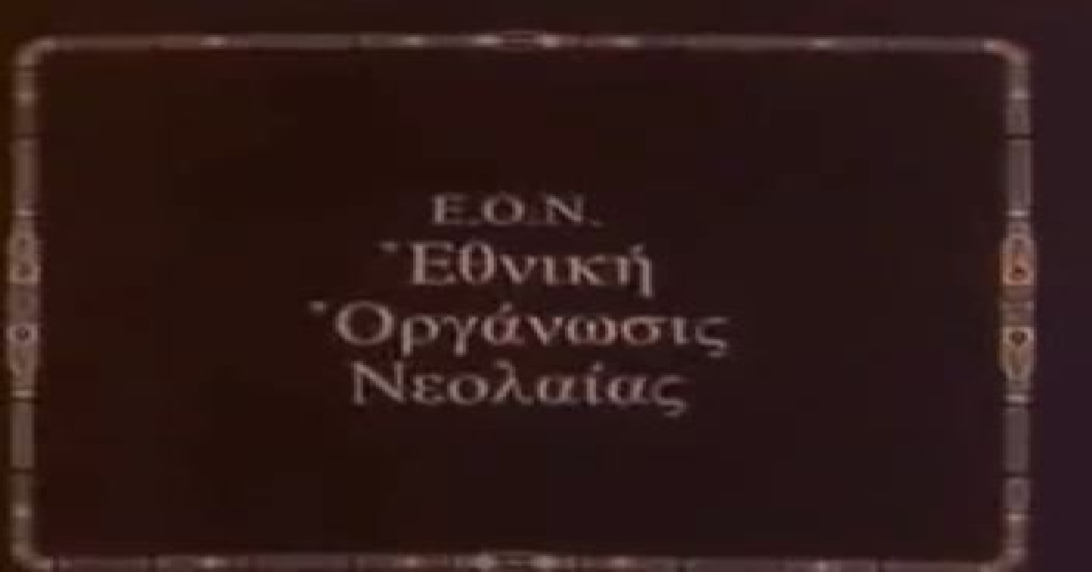

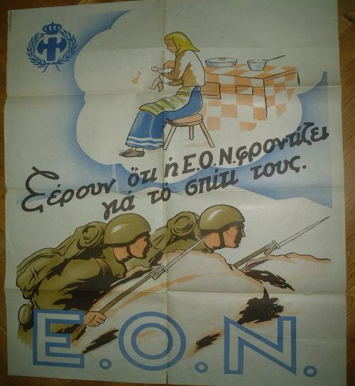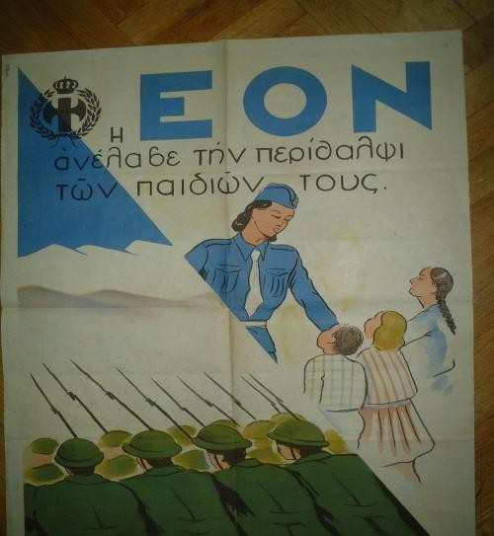

National Organisation of Youth (EON) Anthem
To our sweet homeland the great and heroic You are always the hope Youth of Greece.

Your wholehearted soul National dawn illuminates and the Great Governor will always lead you forward.

Forward for a new Greece, Forward with a Greek heart, Forward, proudly, bravely, Yes, the children of Greece.

Forward, our old glory,
It's time to live again with our great King Forward, ever forward!



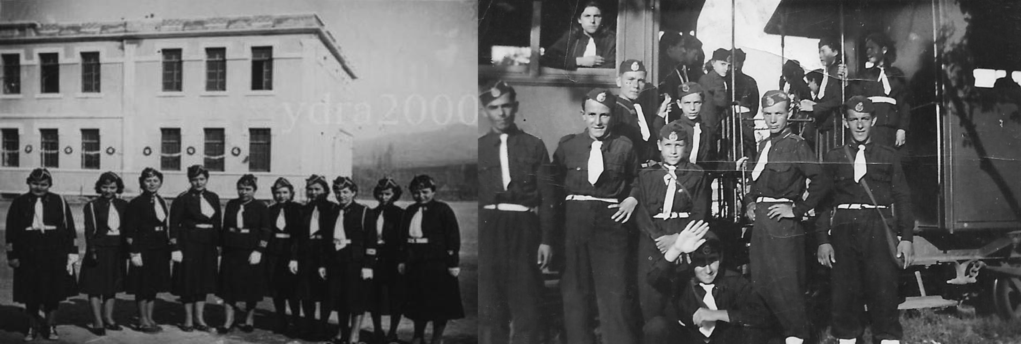

«[…] ΤWearing the uniform was... how can I put it... like wearing a fur or leather today... The kids my age liked it because there was a spirit of brotherhood. I'd say when we were going on a field trip to leave the house so I wouldn't have my aunt nagging me. We felt like we were freeing ourselves from the family. We'd go to the movies for free... we'd have a chance to meet girls. It was a chance to build relationships, not necessarily on a sexual level."
Eleni Machaira, 4th of August youth pictures, Athens 1987, p. 110-111.

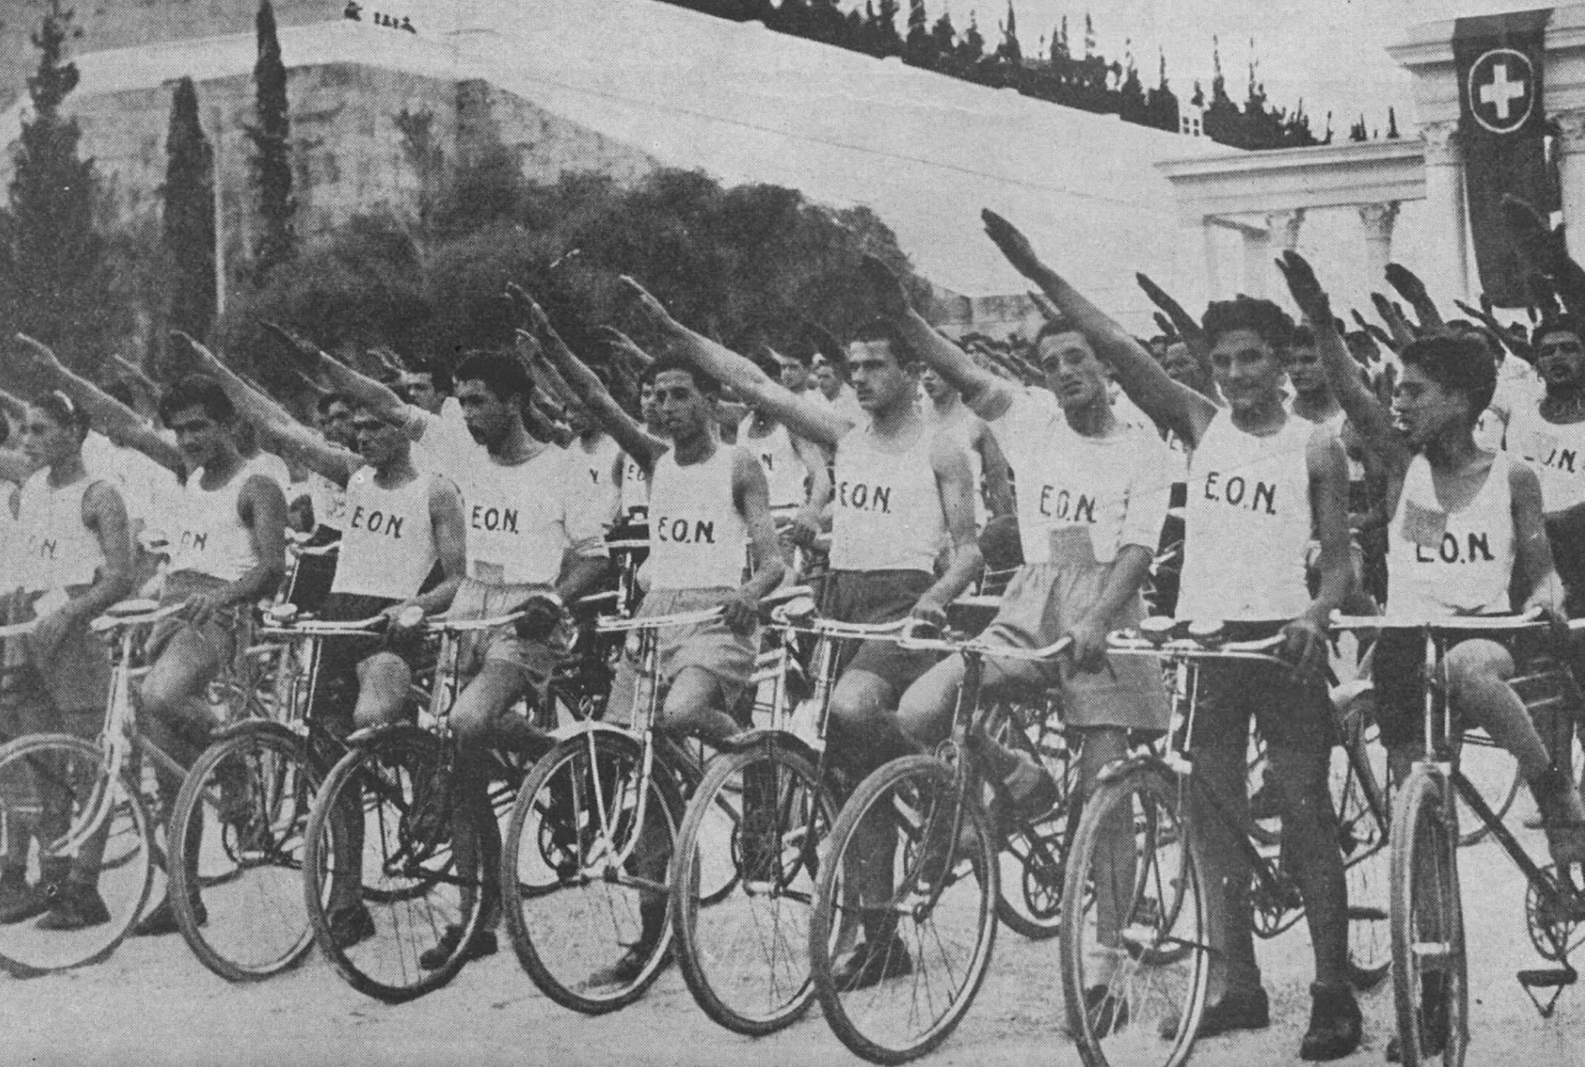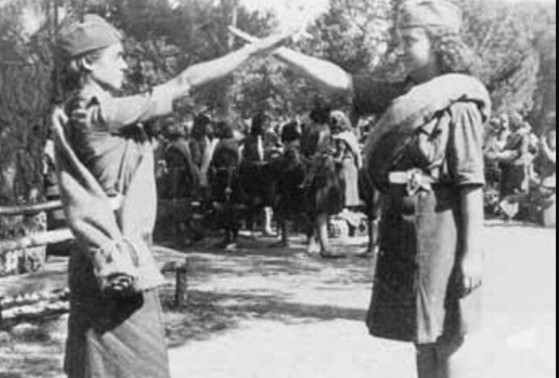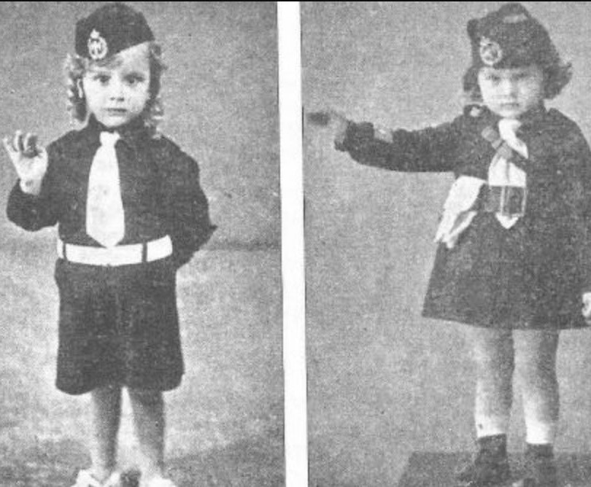

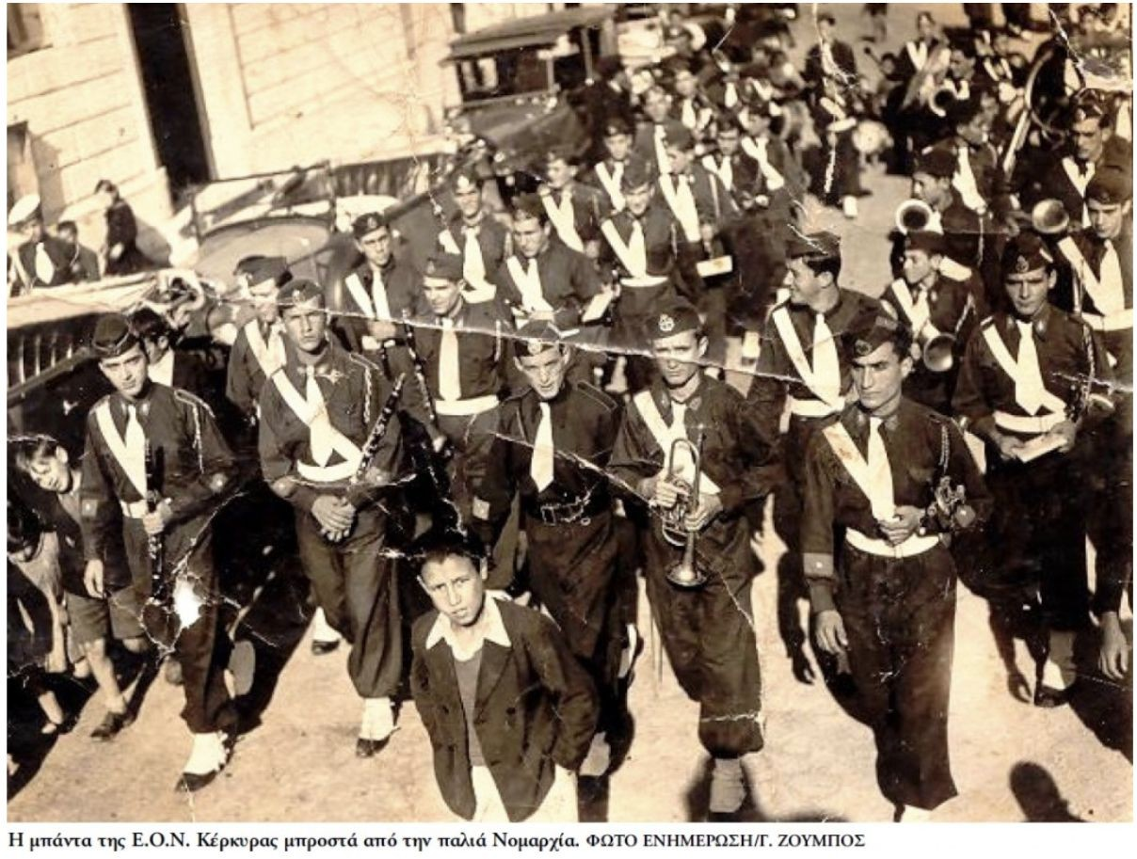



«How could I think the Youth... sucked. It looked like Mussolini's 'kamichi youth' and Hitler's youth... We saw them in the newspapers, we saw the news. What was I supposed to do there? After all, I had graduated from school. They were the ones who went after the young children and students the most. I was in the air club. What's there to do with monkeys and robots?»

Elenia Machaira, 4th of August youth pictures, Athens 1987, p. 110-111.

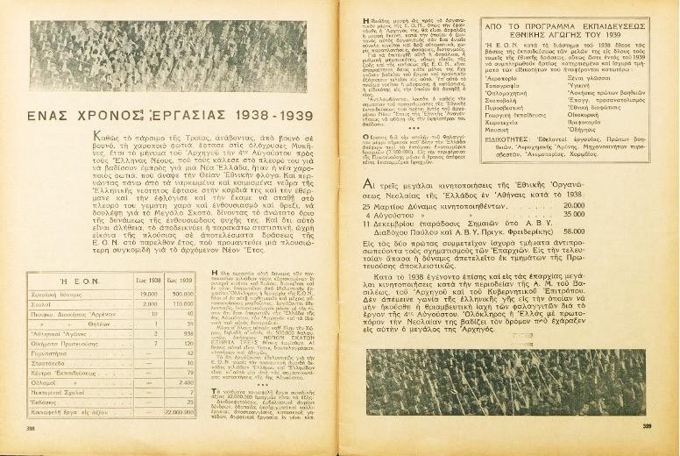


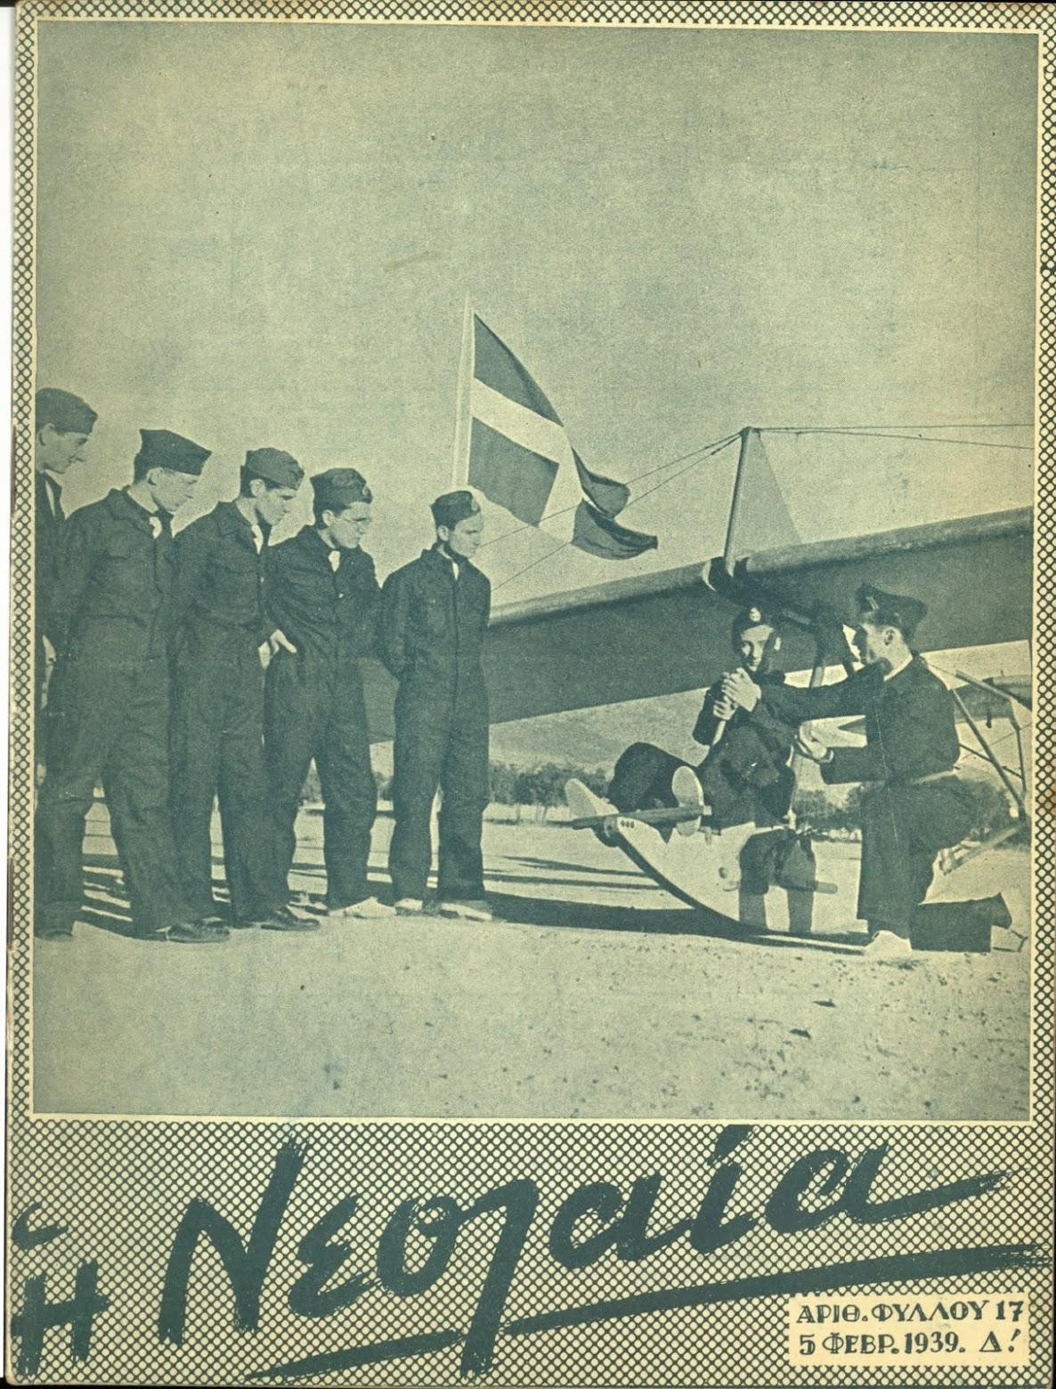

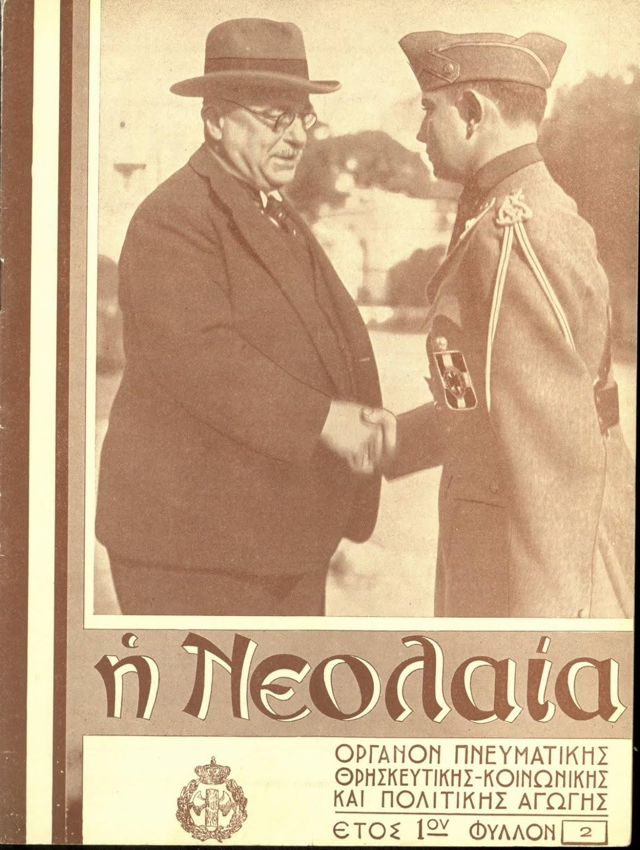

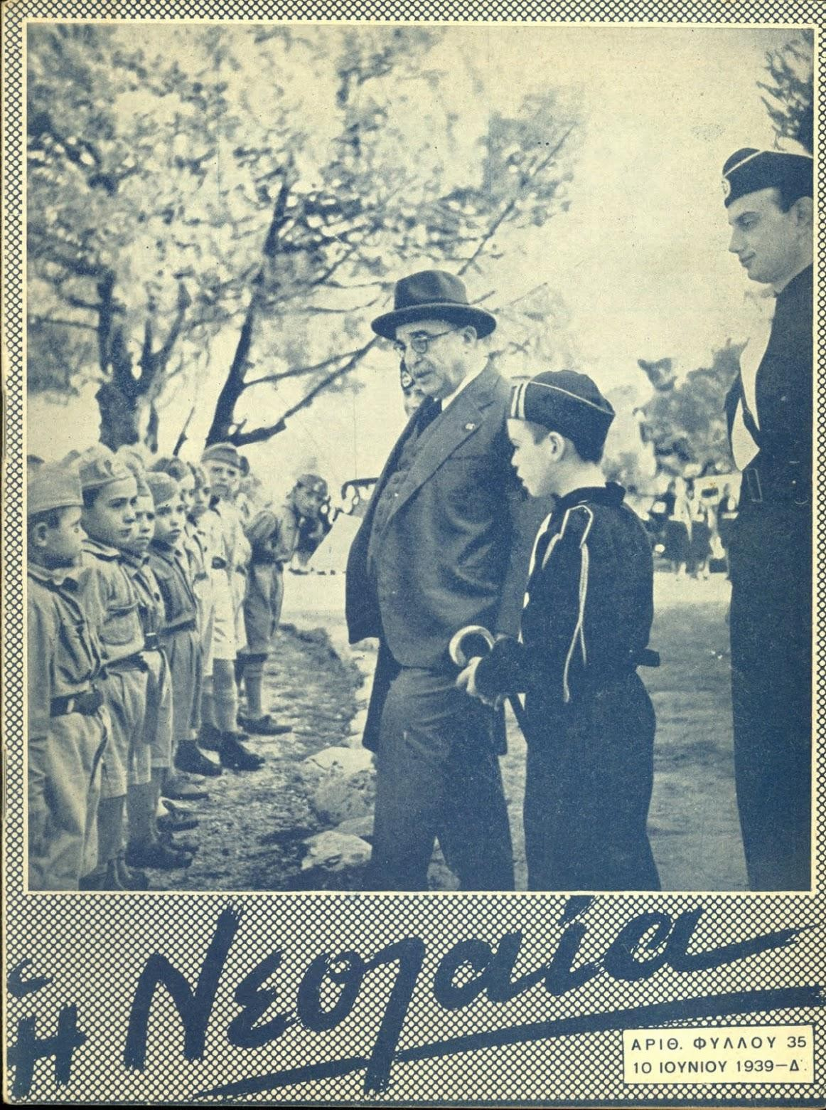

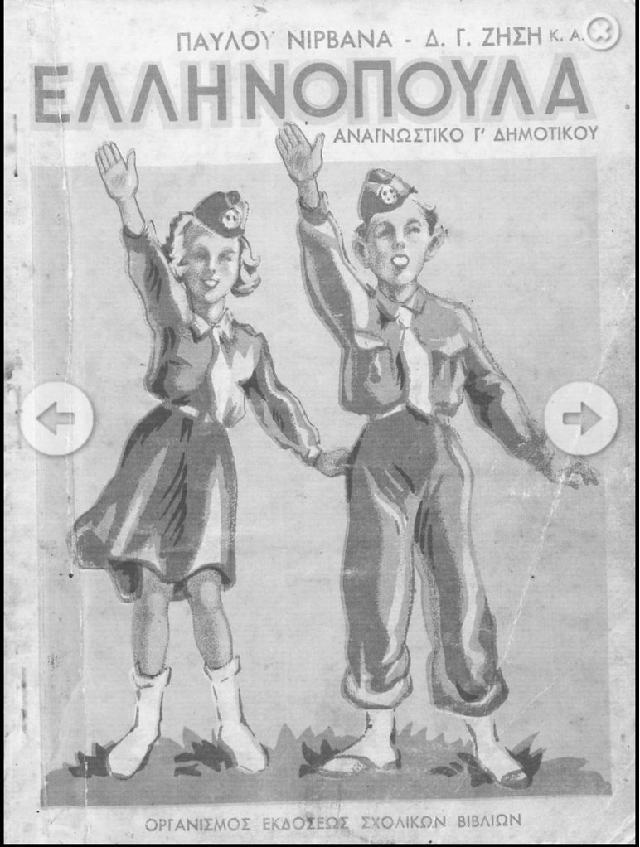
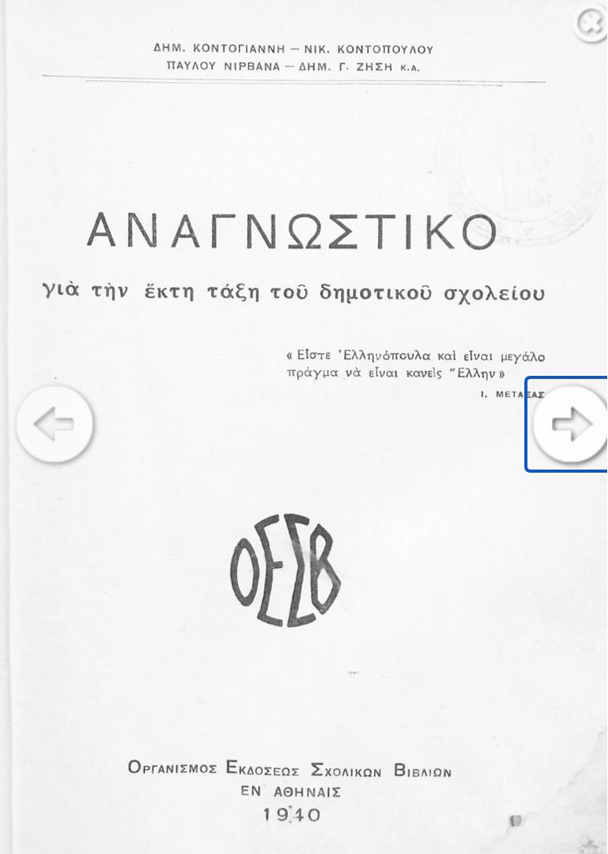



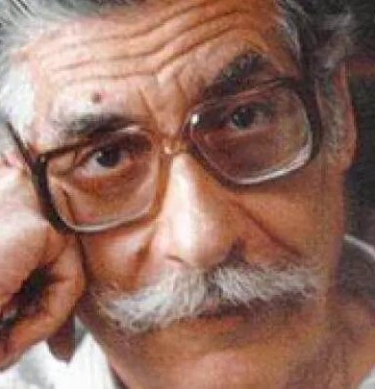
«The apocalyptic book was called Communism in Greece (National Society Publications - τρέχα gyρευε). [...] For a long time this book became my Gospel. Destined for the harshest propaganda, it worked for my ideological awakening like no other book by any Marxist classic or pamphlet. [...] From this book I learned to my amazement that in the years when I was asleep the Party had 159 newspapers of its own, [...] that it had thousands and thousands of followers all over Greece!».
Manolis Anagnostakis,
Poet, (1925-2005)

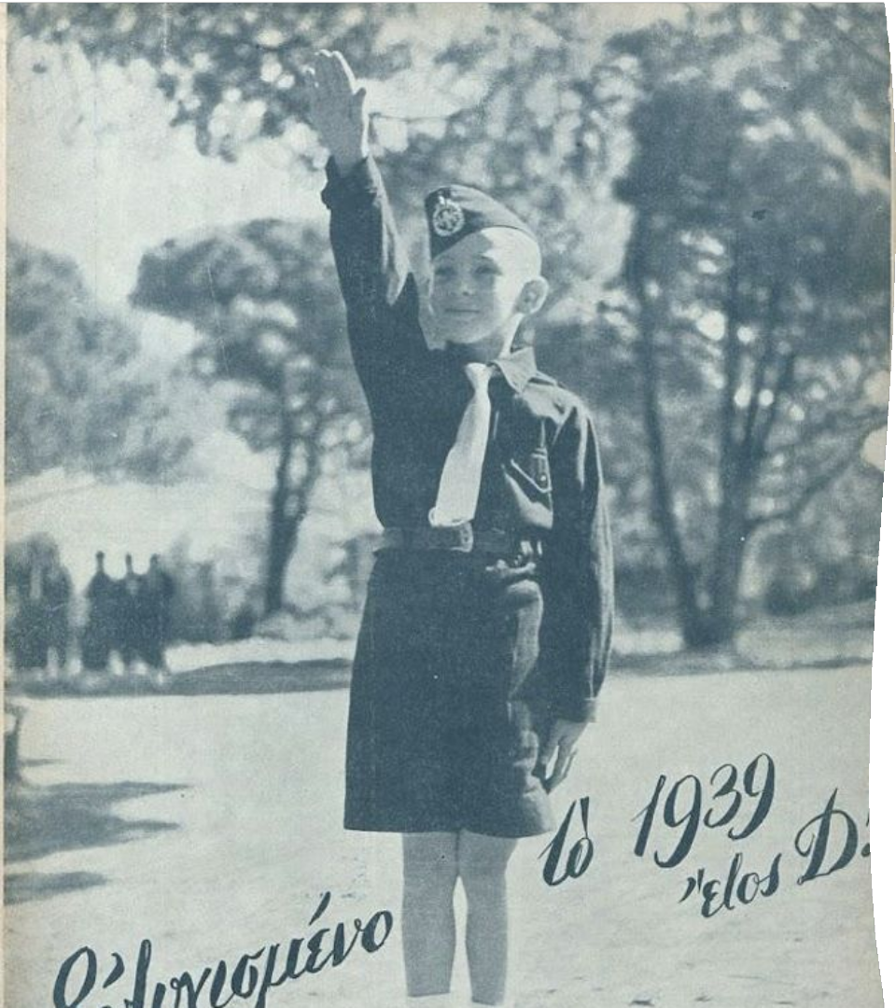

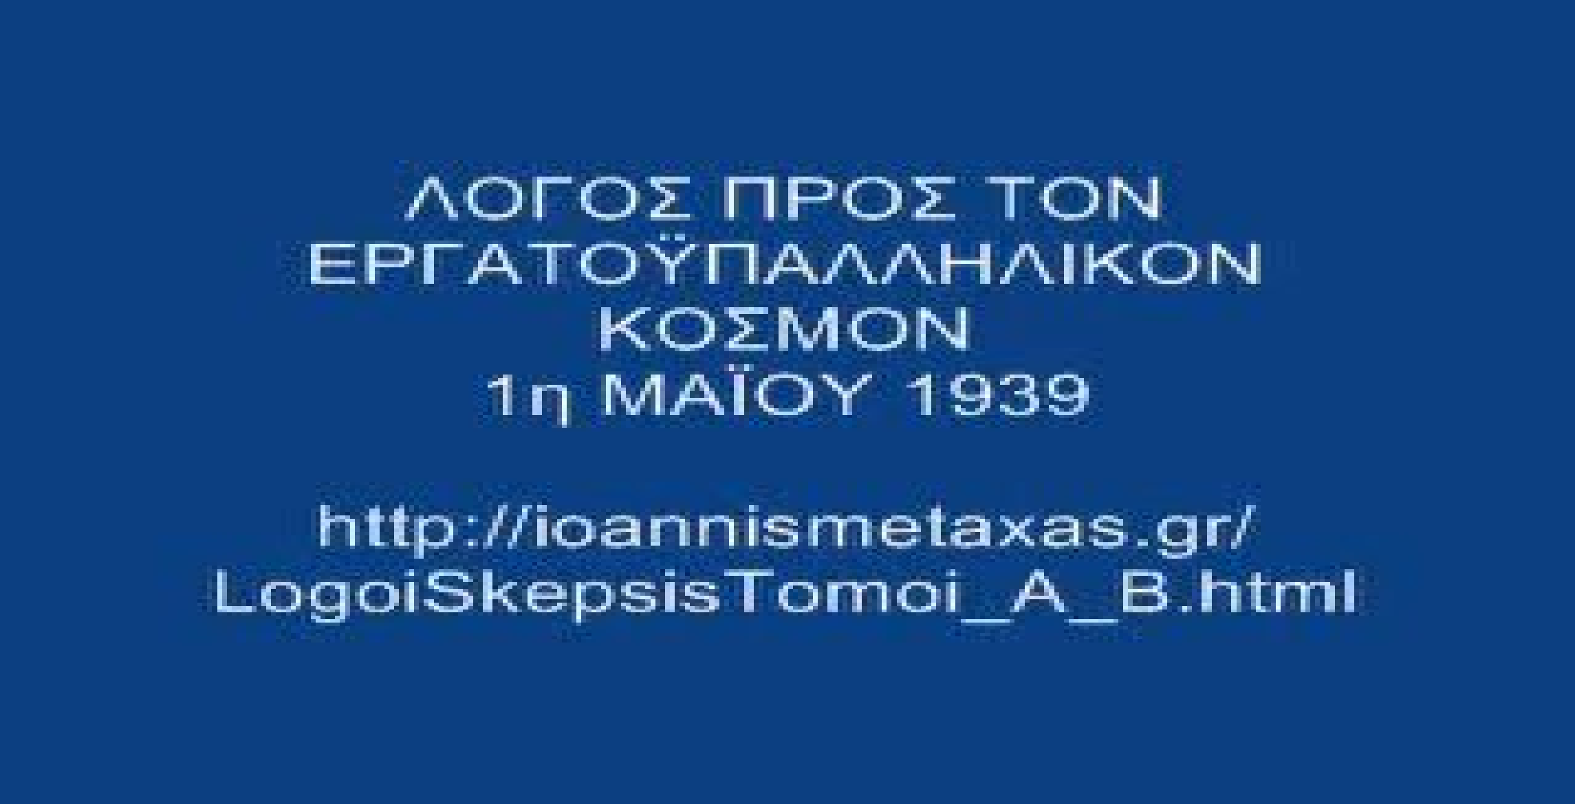


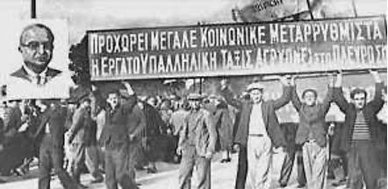

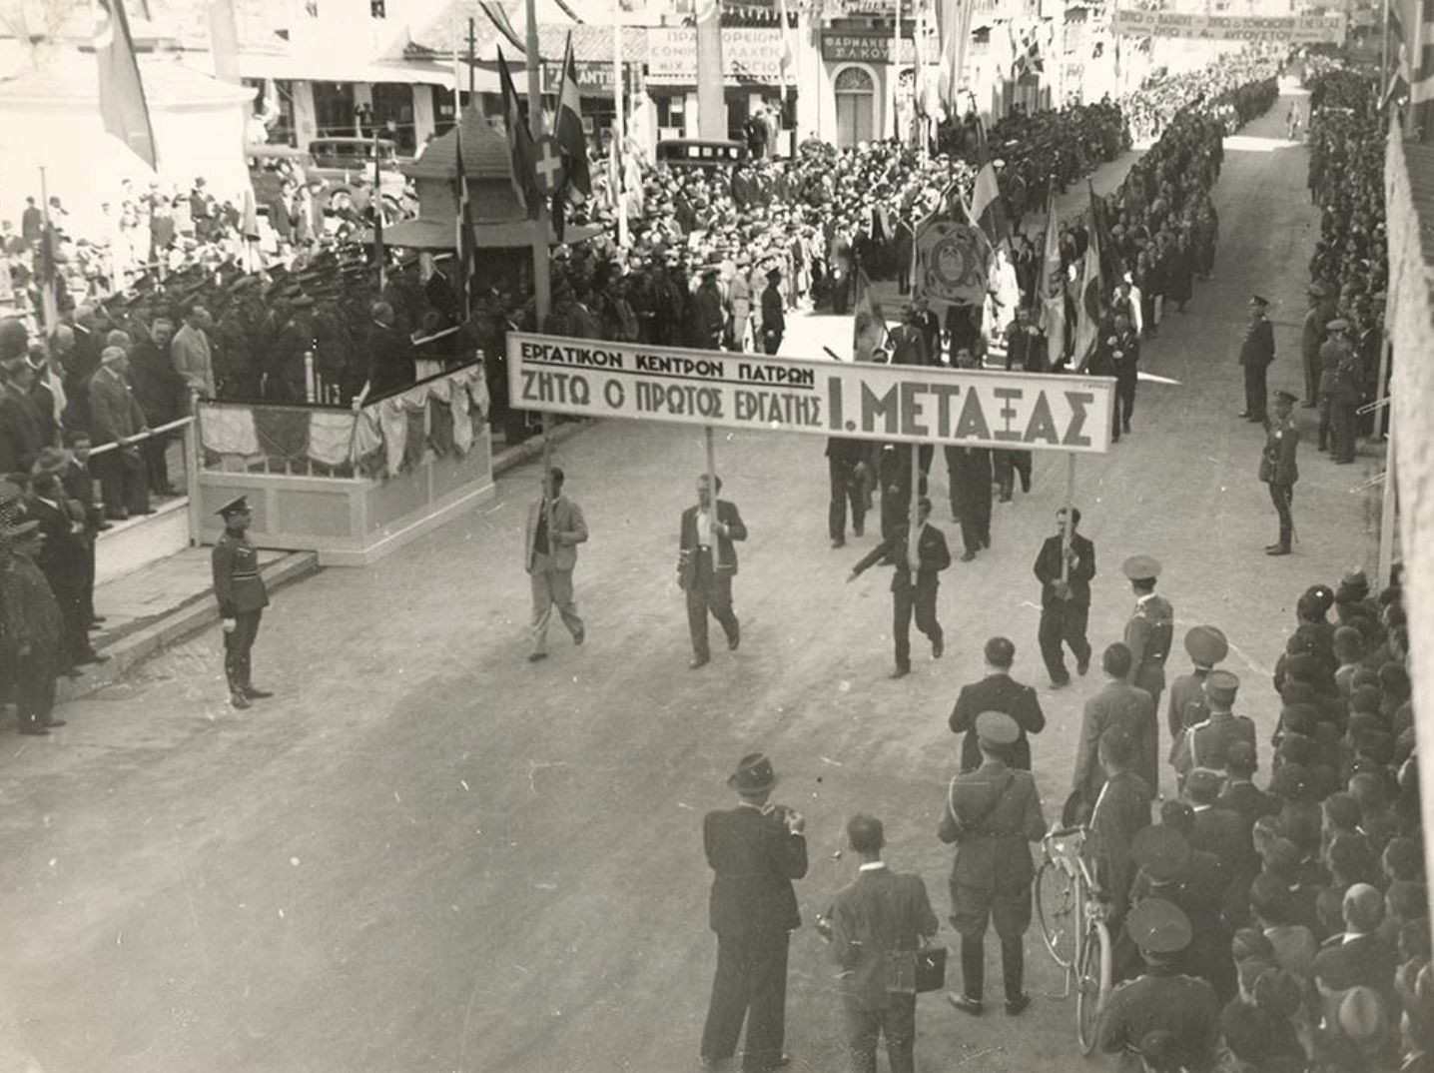
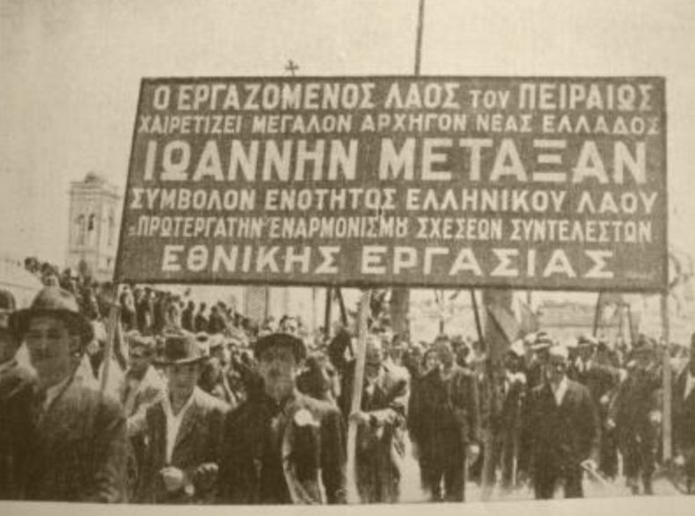

«Ah, then Metaxas had come. 25 dirhams was the lower limit. No one could give you anything less than 25 dirhams. And of course we had the IKA then, when Metaxas did it.
Back then Metaxas had the factories in '36 and he was catching people and you lost your job if you didn't sign up for the E.O.N., we were written up and if we didn't go to the parades you were fired, not kept!!! Yeah, it was mandatory in schools too. [...] In the parades on national holidays. They would come down from the factories and parade. Yes, yes, they came down from
the factories in the parades!!!! As they were in their uniforms and it said the name of this factory, of that factory so-and-so.»
IKA: National Medical Care System EON: National Youth Organisation

(V.L. interview at OPIA , 1/9/89)

«The standard of living and the purchasing power of the daily wage have undoubtedly fallen. In many sectors the measures brought artificial unemployment with the possibility of arbitrary redundancies. Few, especially clerical, sections (bankers, for example) got a little more. Social insurance, while establishing a permanent tax on the worker's and clerk's wage, only applied to industrial accidents - an abuse since 1914 - only to be fully compensated by employers. The insurance of sickness which has begun in two or three centres is almost a mockery in practice, so that it can anything but win supporters of the Dictatorship within the working class, whose life has generally got worse. The unions run by the officials and agents of the State Department (of Security, in the first year of the Dictatorship) have no mass life, although in some branches and in some centres from time to time a number of workers, faced with the lack of any organised means of defence against the employer's attack, have gone to union meetings not to cheer the Dictatorship but to demand the implementation of the promises of the workers».

Pantelis Pouliopoulos from inside the Akronafplia Prison Facility(1939)

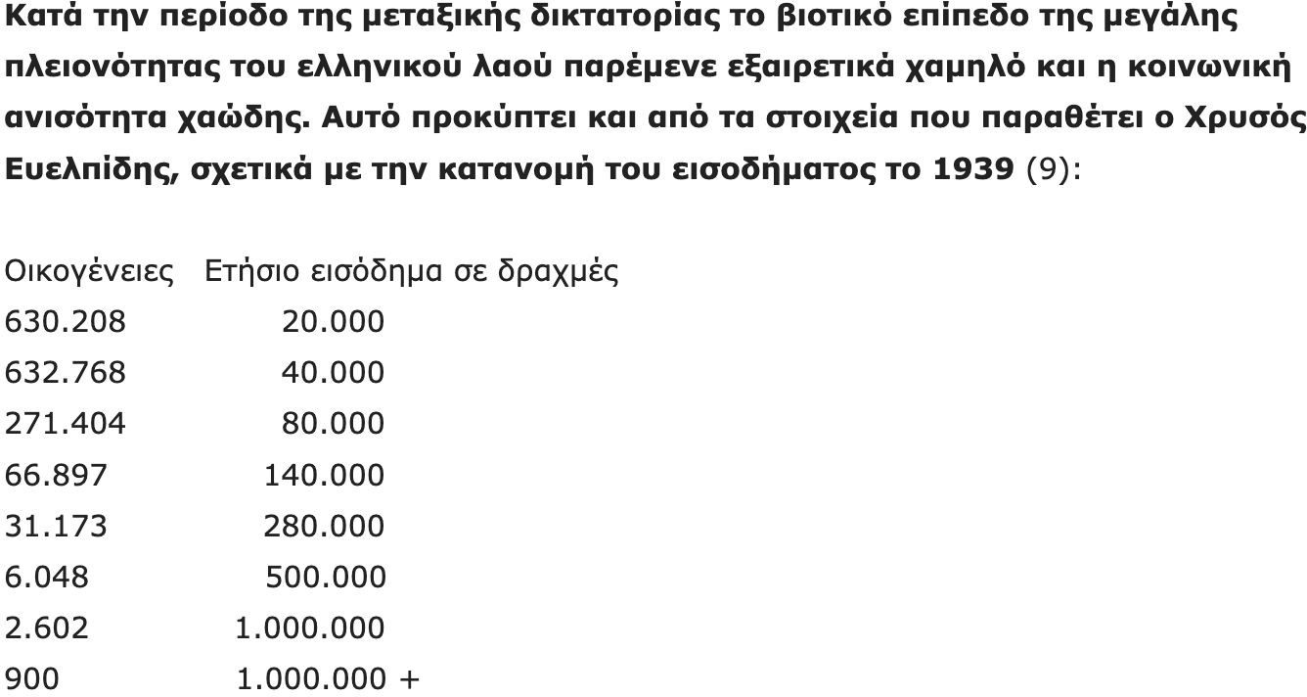


Τεχνικές προπαγάνδας

Invoking the glorious past
Appeal to emotion (fear, hope, anger).
Use of stereotypes and pseudo-scientific arguments.
Personification of the leader as a divine or heroic figure.
Forms of dissemination and support of ideology.
Targeting practices of the enemy and dividing society into "us - them".
Techniques of homogenizing society and the importance of symbols.

Activities
- The students will be divided into 4 groups, each of which will approach
- a) either a different piece of evidence (e.g. textual evidence, poster, video clip) to be analysed according to the methodology approached in class.
- b) either they will create their own propaganda poster or other multimodal text for the same or another regime , using techniques learned.

EXAMPLES SOURCES EXERCISES

There are different ways to analyze a primary or secondary source for different didactic purposes. I have theorized the following with didactic applications:

1. To deepen a narrative text

2. To discover something or solve a problem

3. To contrast different points of view

4. To cast doubt on the hegemonic narrative with other issues

5. To make microhistory

6. To reconstruct a narrative (didactics of the object, among others)

7. To exercise different perspectives based on different questions

8. To uncover a fake

9. For information

