

About the Restaurant
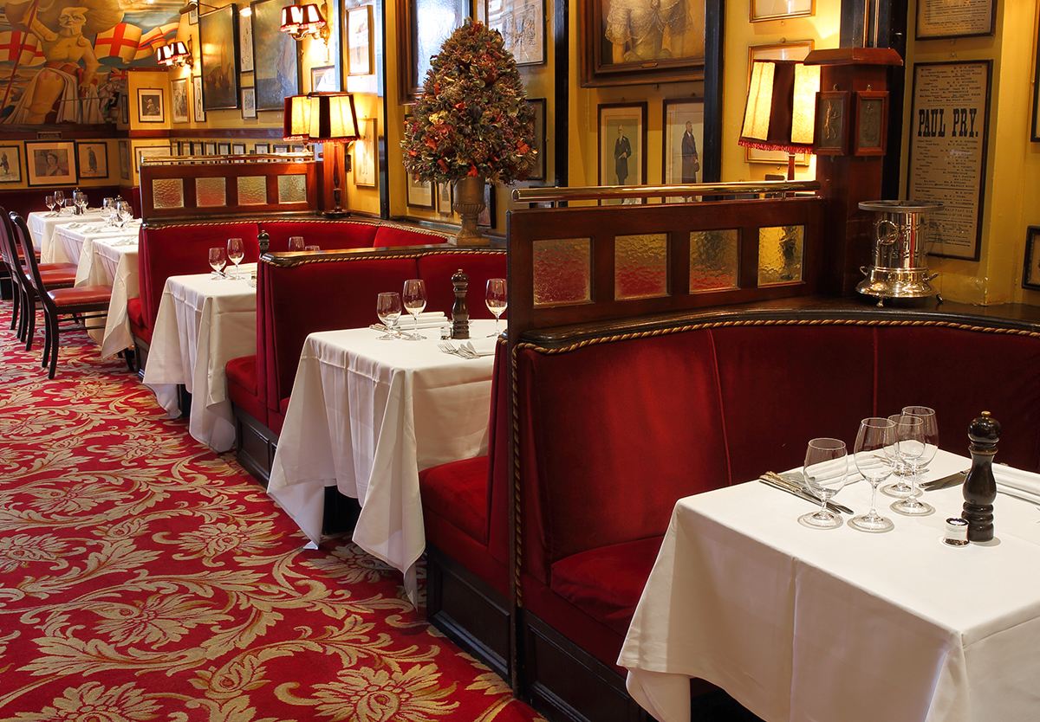
In the year Napoleon opened his campaign in Egypt, Thomas Rule promised his despairing family that he would say goodbye to his wayward past and settle down. No sooner said than he opened an oyster bar in Convent Garden. To the surprise and disbelief of his family, his enterprise proved to be not only successful but lasting.

Contemporary writers were soon singing the praises of Rules’ “porter, pies and oysters”, and remarking on the “rakes, dandies and superior intelligence’s who comprise its clientele”.
Rules still flourishes, the oldest restaurant in London and one of the most celebrated in the world.
In over 200 years, spanning the reigns of nine monarchs, it has been owned by only three families Just before The Great War, Charles Rule, a descendant of the founder, was thinking of moving to Paris; by sheer coincidence he met Tom Bell, a Briton who owned a Parisian restaurant called the Alhambra, and the two men decided to swap businesses. (During the war Tom Bell was an officer in the Royal Flying Corps, and left the running of the restaurant to Charlie, the Head Waiter, who had served Charles Rule for many years.)
In 1984 Tom Bell’s daughter sold Rules to John Mayhew, the present owner. Today Rules seats around 90 people and employs 90 staff.
Rules serves the traditional food of this country at its best – and at affordable prices. It specialises in classic game cookery, oysters, pies and puddings. Rules is fortunate in owning an estate in the High Pennines, “England’s last wilderness”, which supplies training in game management for the staff, exercising its own quality controls and determining how the game is treated.
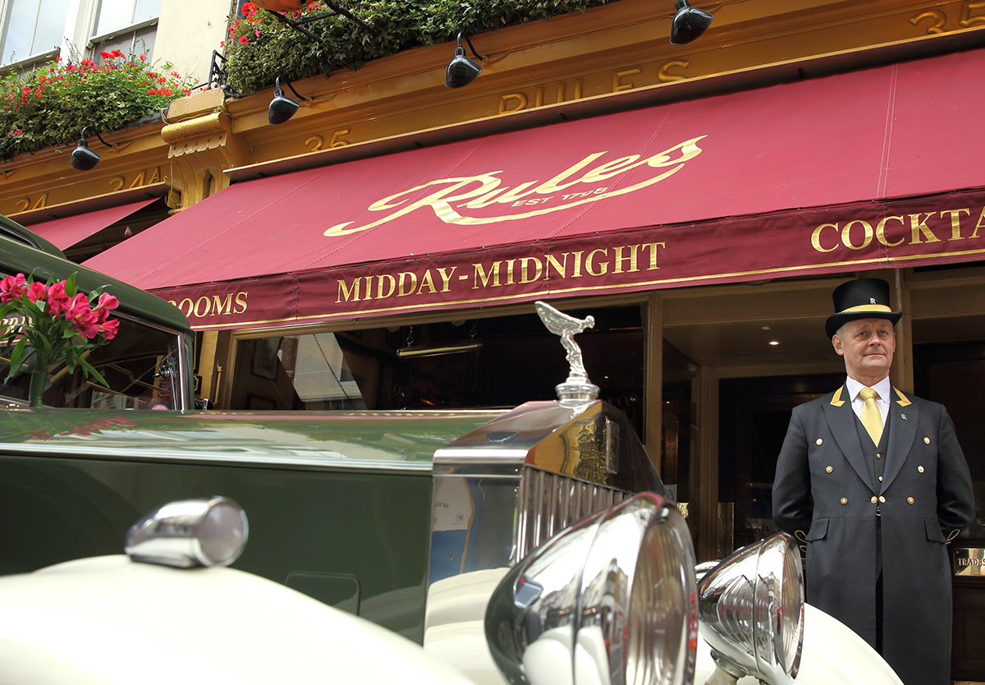

A Star-Studded Past
Throughout its long history the tables of Rules have been crowded with writers, artists, lawyers, journalists and actors. As well as being frequented by great literary talents – including Charles Dickens, William Makepeace Thackeray, John Galsworthy and H G Wells – Rules has also appeared in novels by Rosamond Lehmann, Evelyn Waugh, Graham Greene, John Le Carré, Dick Francis, Penelope Lively and Claire Rayner.
The actors and actresses who have passed through Rules are legion. Down the decades Rules has been an unofficial “green room” for the world of entertainment from Henry Irving to Laurence Olivier, and the history of the English stage adorns the walls. The sibling art of the cinema has contributed its own distinguished list of names including Buster Keaton, Stan Laurel, Charles Laughton, Clark Gable, Charlie Chaplin and John Barrymore.
The past lives on at Rules and can be seen on the walls all around you – captured in literally hundreds of drawings, paintings and cartoons. The late John Betjeman, then Poet Laureate, described the ground floor interior as “unique and irreplaceable, and part of literary and theatrical London”.
Rules a heritage restaurant. There is a demand for the best in life as we are confronted with so much mediocrity. In an age when everyone is deluged with homogeneous brands, we like to create the special. There is a real unfulfilled need and desire to experience it.

Meet The Team
Rules has 90 employees made up of 35 Chefs, 3 Directors, 3 Housekeepers & Maintenance, 4 Managers, 5 Reservations & Back Office, 38 Waiting & Wine and 1 Proprietor.
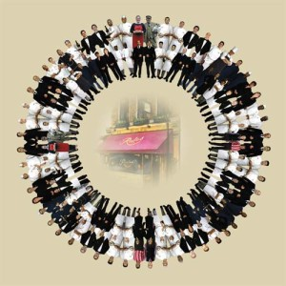
They have come from the following countries: Algeria, Austria, Australia, Belarus, Belgium, Bolivia, Brazil, Cameroon, Canada, Chile, China, Croatia, Czechoslovakia, Denmark, Egypt, England, Ethiopia, Finland, France, Germany, Greece, Holland, Indonesia, Iraq, Ireland, Israel, Italy, Jamaica, Japan, Kenya, Malaysia, Maldives, Malta, Mauritius, New Zealand, Nigeria, Norway, Pakistan, Poland, Portugal, Russia, Scotland, South Africa, Spain, Sri Lanka, Sudan, Sweden, Switzerland, Turkey, U.S.A. and Zimbabwe. Including: Agnostics, Atheists, Buddhists, Christians, Hindus, Jews and Muslims.

Private Dining & Events
From the moment you step through the door at Rules, you feel you are in a place that exudes history, understated luxury and warmth; our elegant and discreet private dining rooms epitomise this feeling. Dedicated to literary figures of distinction, novelist Graham Greene and Poet Laureate Sir John Betjeman, both these rooms are wood panelled with red leather chairs and Sketch Victorian artwork, offering charming spaces which are ideal for a variety of events from corporate dinners to wedding breakfasts. Our seasonal menus bring you carefully sourced ingredients, a stunning wine list, classic cocktails, fresh flowers and our highly praised staff all contribute to the success of each event.
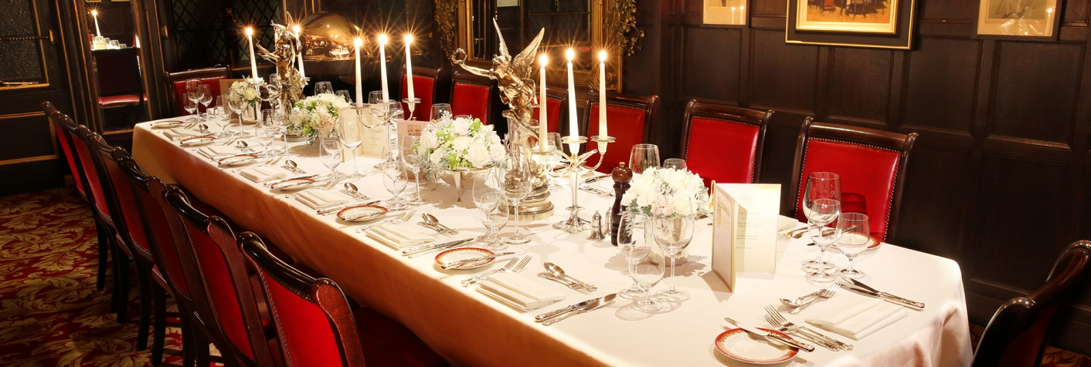
Private Dining
Situated in the heart of Covent Garden, our unique private dining rooms offer elegant and charming surroundings ideal for entertaining clients and colleagues and for celebrating with family and friends.
The John Betjeman Room accommodate up to 10 for dining whilst the Graham Greene Room can seat up to 18 for dining and 25 for standing buffets and receptions. Both rooms are situated on the same floor and offer delightful facilities for private dining guests. Our delicious, seasonal dishes can be tailored to your requirements as we are always delighted to assist in creating bespoke menus and cocktails; we provide place cards and printed menus, beautiful fresh flowers, and a dedicated private dining team to ensure your event exceeds your expectations whether it be a corporate dinner, an anniversary celebration or a wedding breakfast.

Meetings
Our discreet rooms with their beautiful latticed windows offer ideal meeting space for up to 18 people. There is no room hire charge for breakfast meetings and menus start at £28 per person for a continental selection or £35 per person for a hot option for a minimum of 6 people.
Our daily delegate rate of £90 per person includes morning coffee break, working lunch, afternoon tea and cake as well as Wi-Fi and a 42-inch screen for a minimum of 6 people.
For private dining room enquiries, please email Philip Goodchild pr@rules.co.uk or telephone 020 7836 5314.

Μεταφραστικές οδηγίες
Το κείμενο αφετηρίας είναι απόσπασμα από μια έντυπη διαφημιστική μπροσούρα του εστιατορίου Rules στο Λονδίνο που απευθύνεται στους τακτικούς και νέους πελάτες του.
Η μετάφρασή του αποσκοπεί στη δημιουργία μιας αντίστοιχης, έντυπης διαφημιστικής μπροσούρας στα Ελληνικά για ελληνόφωνους, τακτικούς και νέους πελάτες του εστιατορίου.
Δεδομένων των περιορισμών που θέτει η έντυπη έκδοση στην έκταση του κειμένου, το μετάφρασμα δεν πρέπει να ξεπερνά τις 1.000 λέξεις.

