How to Adapt to British Culture
The United Kingdom of Great Britain and Northern Ireland is the fifth richest country in the world and one of the most diverse nations in the whole of Europe. This article will show you how to adapt to the varied culture of England, Scotland, Wales and Northern Ireland.

Steps
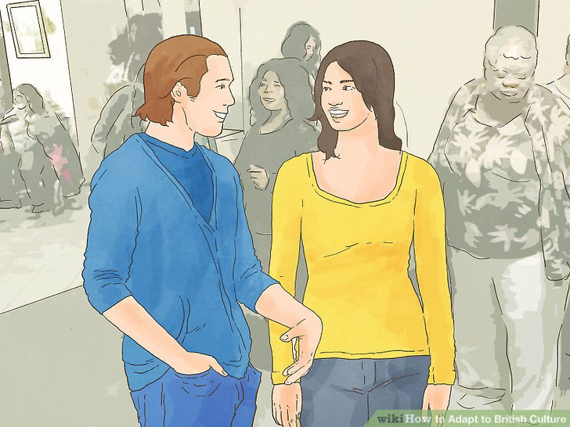
1. Forget the stereotypes. Many of the long established stereotypes are not relevant in the UK today. Don't assume that everyone is going to fall into the category of the beer swilling, rotten-toothed tea addict. Abandoning pre-conceived ideas of people and culture will allow you to be more open-minded and readily able to assimilate the culture you find yourself in.

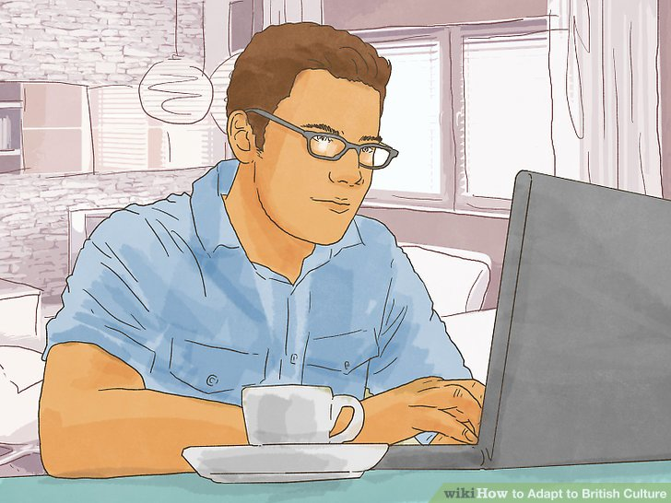
2. Understand the differences. The United Kingdom is comprised of different countries (England, Scotland, Northern Ireland and Wales) and numerous different regions that all have their very own and very different traditions, dialect and even language. Understanding that culture in a remote village in the Outer Hebrides up the north of Scotland will not be the same as a southern English spa town will help you to avoid making mistakes and generalizations.

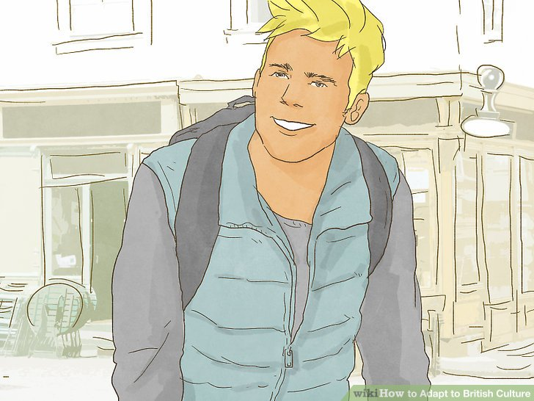
3. Get used to small spaces. The United States is not only a huge country but they are used to bigger cars, houses and spaces. Like many European nations, the UK does not have the luxury of space. Houses, apartments (flats), cars and appliances are all smaller than you are accustomed to, so become more familiar with smaller areas.
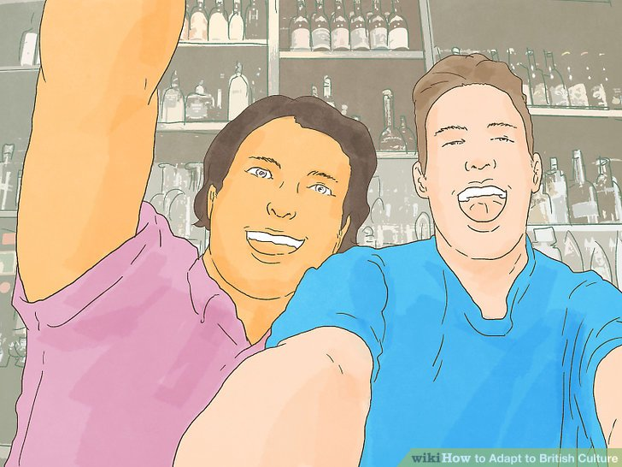
4. Go to the pub. The pub is a very important part of British culture and nothing will immerse you in more than a good old fashioned pint of beer. Students, work colleagues, friends and family meet in the pub and it is used as a focal point of social contact.

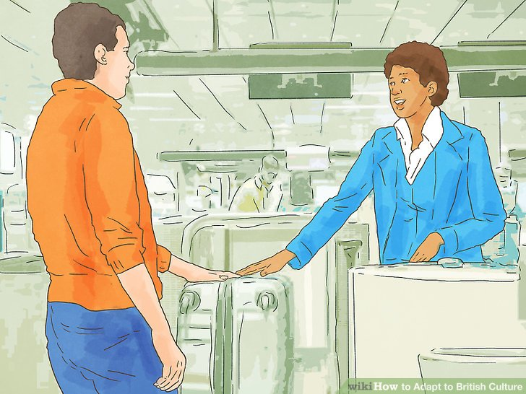
5. Be polite. Adapt by blending into the crowd. Always apologize for bumping into someone, even if it was their fault, as it makes you out to be a kinder person. Respect people's personal space and always wait in line (called a queue in the UK).

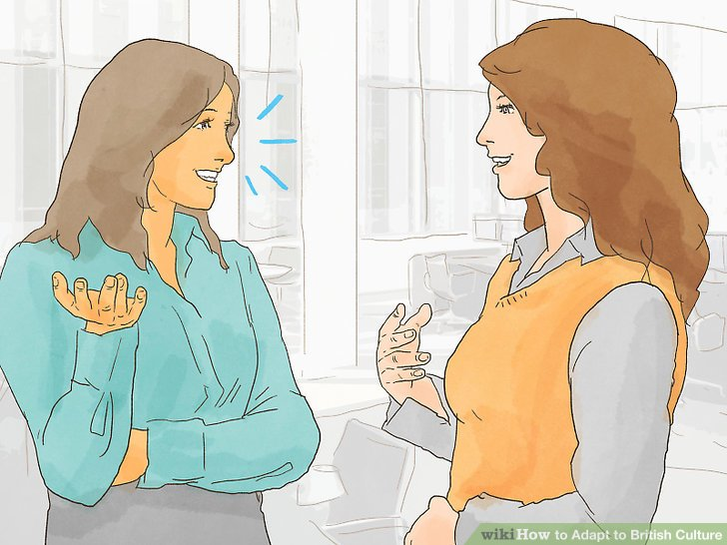
6. Accept the jokes. One of the most confusing aspects of British culture is humor. Bantering or "taking the mickey" are all ways to describe making fun of someone but this isn't necessarily a bad thing. Teasing someone is a common way to show affection. As one Briton put it, "you never make fun of someone you don't like."

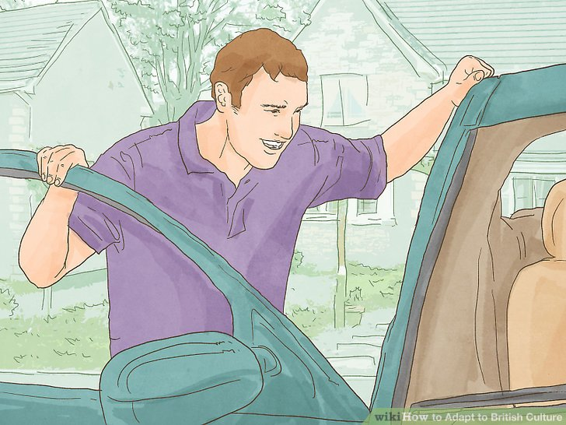
7. Get used to the driving. The British drive on the left-hand side of the road, and the steering wheel is on the right-side of the vehicle. Be sure that you drive on the left-hand side or the consequences can be unpleasant. Be especially careful with your turns and remember that right turns in the UK cross opposite traffic in the same way that left turns do in the USA and other countries that drive on the right.

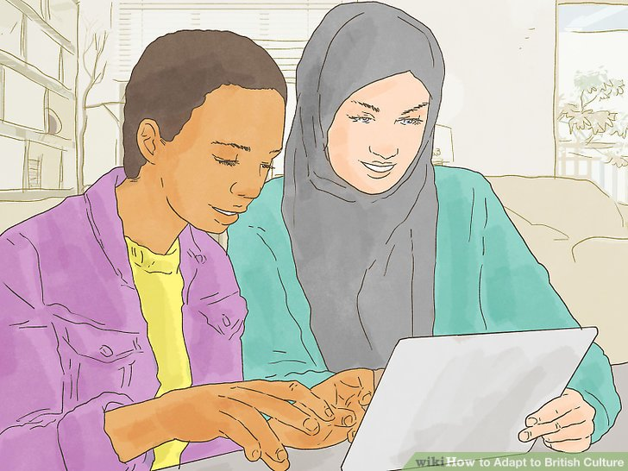
8. Get used to the language. The British use different terminology and spell and pronounce words differently. Look around on the internet or buy books which have lots of help about the particular language which the British use.

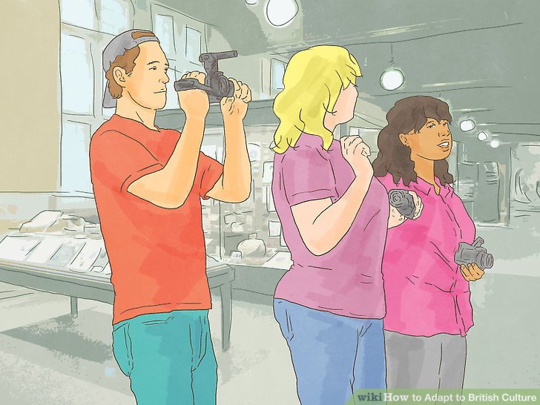
9. Enjoy the diversity. Many UK cities are ethnically diverse. Birmingham, Leicester and London, amongst other cities, all have large Asian populations. Polish influences are spreading around the country too. It's not all Shepherd's pie and Bangers and mash, have a curry, shop in a Polish Grocery Store, get a Turkish kebab or have a Chinese takeaway. Manchester, London and Newcastle to name a few cities, have great Chinatowns.

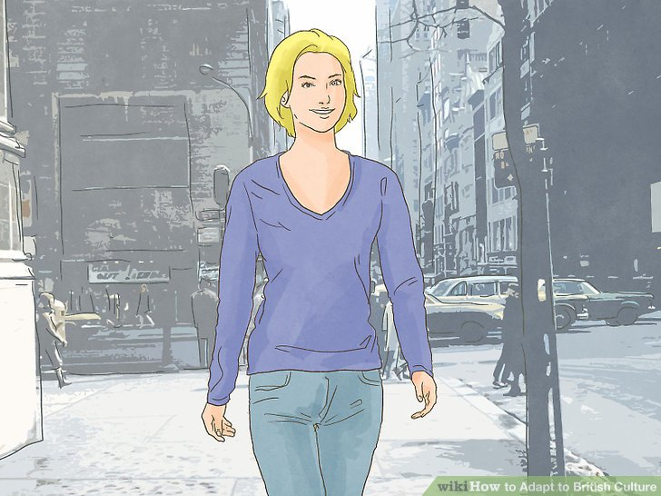
10. Experience the antiquity. History, antiquity and "retro" are abundant in the UK. Many houses, public buildings, churches, cathedrals and commercial buildings in the UK are considerably older than anyone from the US will be used to.


11. Explore other cities in the United Kingdom. There's more to the UK than London. Although London is an excellent city and the most popular in the United Kingdom, there are many other cities filled with culture and wonder.
Nottingham is a fantastic city to visit. It's certainly smaller than London, but you'll immediately find everything is much cheaper there, as it is in many places outside of London. Jay McGuinness from the popular British boy band, The Wanted; is from Nottingham.
Also, despite its bad reputation, Birmingham is a great city, and is notable for being the birthplace of heavy metal music. Not so much around the outer areas, the city centre is full of shops with the amazing architecture, a Chinatown and the canal. The lush green hillsides, dramatic moors, wide expansions of marshland and stunning coastal countryside are defining features of the UK, and should be explored.

Πηγή: https://www.wikihow.com/Adapt-to-British-Culture#Questions_and_Answers_sub

Οδηγίες
Εντολέας-Χρήστης της μετάφρασης: ο(οι) διαχειριστής(ές) μιας ιστοσελίδας όπως η παρακάτω: http://www.steppingstone.gr/index.php
Παραλήπτης της μετάφρασης: Έλληνες που ενδιαφέρονται να σπουδάσουν ή να εργαστούν στη Μεγάλη Βρετανία.

