Elements of a Good Presentation
Making a good presentation can be easy if you include the following elements:
1. Simple slides, with no more than one concept per page, and no more than 25-30 words per page.

Good | 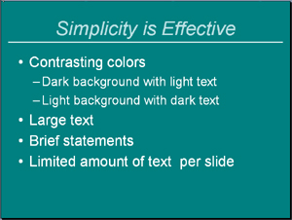
Not so Good | 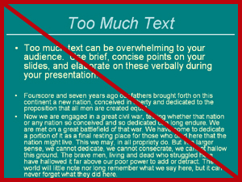
2. Text and images kept within a reasonable distance from the edges of the slide. This prevents the slide from looking over-crowded.

Good | 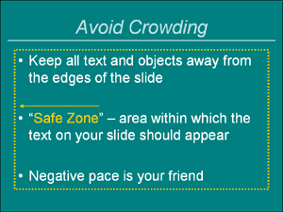
Not so Good | 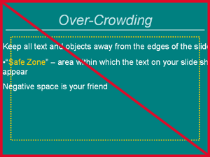
3. Slides that are easy to read. Avoid flashy color schemes, fonts, and animation. These features should complement a presentation, and not be the presentation itself.

Good | 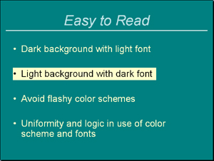
Not so Good | 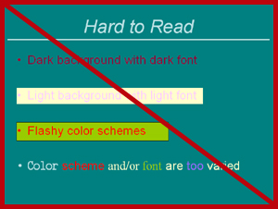
NOTE: Choose "Slide Design - Color Schemes" from the task pane menu to see a variety of pre-designed schemes you can apply to your slides.
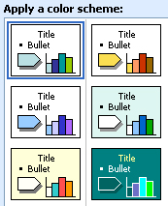

4. A speaker who uses the slides as prompts and not as a script to be read aloud. Sometimes audiences find it distracting to try to read and listen at the same time.

