ΕΛΛΗΝΕΣ ΒΙΝΤΕΟ ΚΑΛΛΙΤΕΧΝΕΣ*

ΜΑΝΘΟΣ ΣΑΝΤΟΡΙΝΑΙΟΣ

Teratogonia Video poem
https://www.youtube.com/watch?v=VpZJSgkxoQI&ab_channel=ManthosSantorineos
LOST MEMORIES, 1989-94
https://www.youtube.com/watch?v=5psZjxJxM1g&ab_channel=ManthosSantorineos
ΑΛΦΑΒΙΛ, 2021
https://www.youtube.com/watch?v=rzvQ9Pqsyd0&ab_channel=ManthosSantorineos
ΑΛΦΑΒΙΛ, ΖΑΝ ΛΥΚ ΓΚΟΝΤΑΡ
https://www.youtube.com/watch?v=CzaATgGHmy0&t=86s&ab_channel=RialtoPictures

VOICE ART: MIKHAIL KARIKIS
https://www.youtube.com/watch?v=YJEcA3rUOnM
JANIS RAFA
https://www.youtube.com/watch?v=Ckt8uLxTJ2I&ab_channel=BiennaleChannel
ZOE KRAVVARITI, VIDEO ART ON HOUSE/HOME
https://gsashowcase.net/zoe-kravvariti/

EVA PAPAMARGARITI
https://www.art-works.gr/en/fellows-news-en/eva-papamargariti-screens-series-online-by-the-new-museum/
https://www.art-works.gr/en/fellows-news-en/eva-papamargariti-screens-series-online-by-the-new-museum/

ΓΙΟΥΛΑ ΠΑΠΑΔΟΠΟΥΛΟΥ ΚΑΙ FESTIVAL MIDEN (https://www.facebook.com/festivalmiden)
https://vimeo.com/gioulapapadopoulou?fbclid=IwZXh0bgNhZW0CMTAAAR2FBlxrXcKpRJmFuiWVrq8AxHTEwOP4uU-_0c9TxbO5FqEBRQyKMRKMc_A_aem_r_MLaQmFafceJe2q1hMzFw

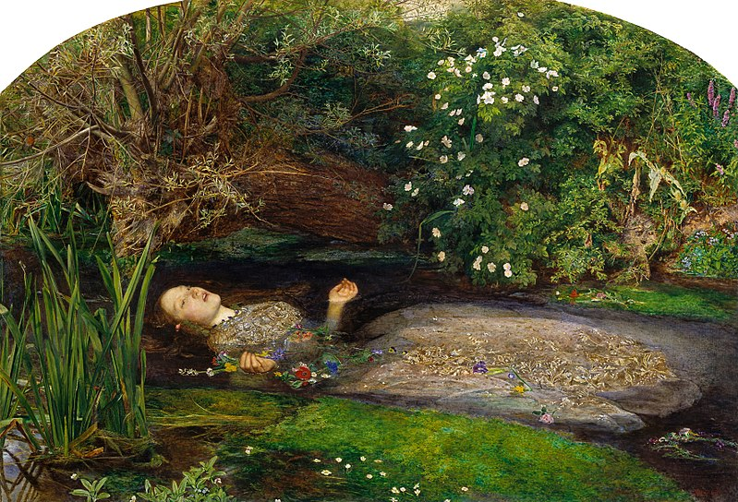
OPHELIA, JOHN EVERETT MILLAIS, 1851

https://www.youtube.com/watch?v=G_aTpl1slkw&ab_channel=PhotographyCenterofThessaloniki
ΜΑΙΡΗ ΖΥΓΟΥΡΗ
https://vimeo.com/36403528

*Η συγκεκριμένη λίστα είναι ενδεικτική και δεν περιλαμβάνει πολλά άλλα ονόματα αξιόλογων καλλιτεχνών

