Video and text
Luigi serafini
https://ubu.com/media/text/vp/031_Serafini_Codex_Seraphinianus_1978.pdf
signalist poems
https://ubu.com/media/text/vp/005_Vicic_Thirty_Signalist_Poems_1973.pdf
signalism
https://www.miroljubtodorovic.com/pages/signalism_in_lexicons.htm
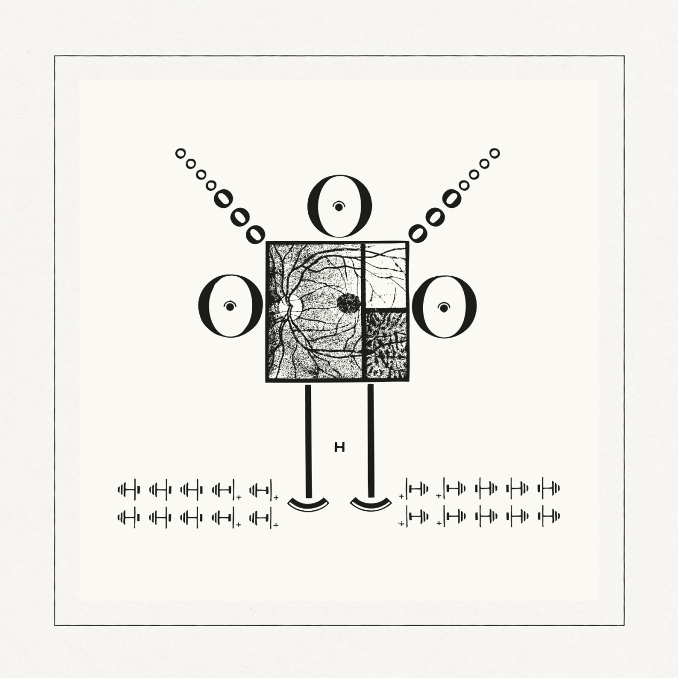
https://www.innervisions.com/archive/miroljub-todorovi

the pipe
https://ubu.com/media/text/vp/nichol_the_pipe_1973.pdf
Nektarios Pappas
https://nektariospappas.com/projects-2/
Θέμης Ανδρεάδης, Θα πάω στη ζούγκλα με τον Ταρζάν
https://www.youtube.com/watch?v=KBnckeRtO3g
Βίκυ Μοσχολιού, Άσπρα κόκκινα κίτρινα, μπλε
https://www.youtube.com/watch?v=987T2axDLdI

LAURIE ANDERSON
https://www.youtube.com/watch?v=xqb-4-IqHMc
i ll be your mirror, adelaide
https://www.adelaidefestival.com.au/events/2024-events/i-ll-be-your-mirror/
εκθεση στη σουηδια
https://www.youtube.com/watch?v=ymFOGWNqpKc
Douglas Gordon, Philip Parreno, 2005 A 21ST CENTURY PORTRAIT
https://www.youtube.com/watch?v=tD1ztRyZiRs

Eija Liiza Ahtila
https://crystaleye.fi/eija-liisa_ahtila/films/me-we-okay-gray

https://www.youtube.com/watch?v=zV0z0gL1xzM
Η καλλιτέχνης εξηγεί τα έργα της+αποσπάσματα
https://www.youtube.com/watch?v=Y-XVdQgeeEs

