TERM PAPER PROJECT POSTER TEMPLATE

(2-3 PPT SLIDES, aspect 16:9 recommended)

Course: SCHER2: European Institutions, Financial Instruments, and Cultural Heritage

FINAL PROJECT PRESENTATION (10’, followed by a 5’ discussion

OVERVIEW

Your poster should include the following elements in whatever arrangement on the poster slide you prefer)

- Tentative Project Title
- Student Name | Country / Site | EU Instrument(s)
- Heritage-Security Issue (2–3 sentences)
- Why is it a human security issue related to heritage?
- EU Legal / Policy Basis (bullet points, concise)
- Financial instruments
- EU programs
- EU Framework funding-supported (e.g. Europa Nostra)
- The heritage-(human) security nexus
- Referent object;
- risk mechanism;
- mitigation instruments;
- unintended consequences;
- test of success
- “The Bottom Line”
- Ultimately, who where the implementing actors
- How was their “actorness” defined?
- What actions would you have recommended to assure success?

- Use Visualizations (as needed) – see below
- Findings / Insights (5 bullets max)
- Question for Discussion

_________________________________________

FYI, example of the midterm poster’s arrangement

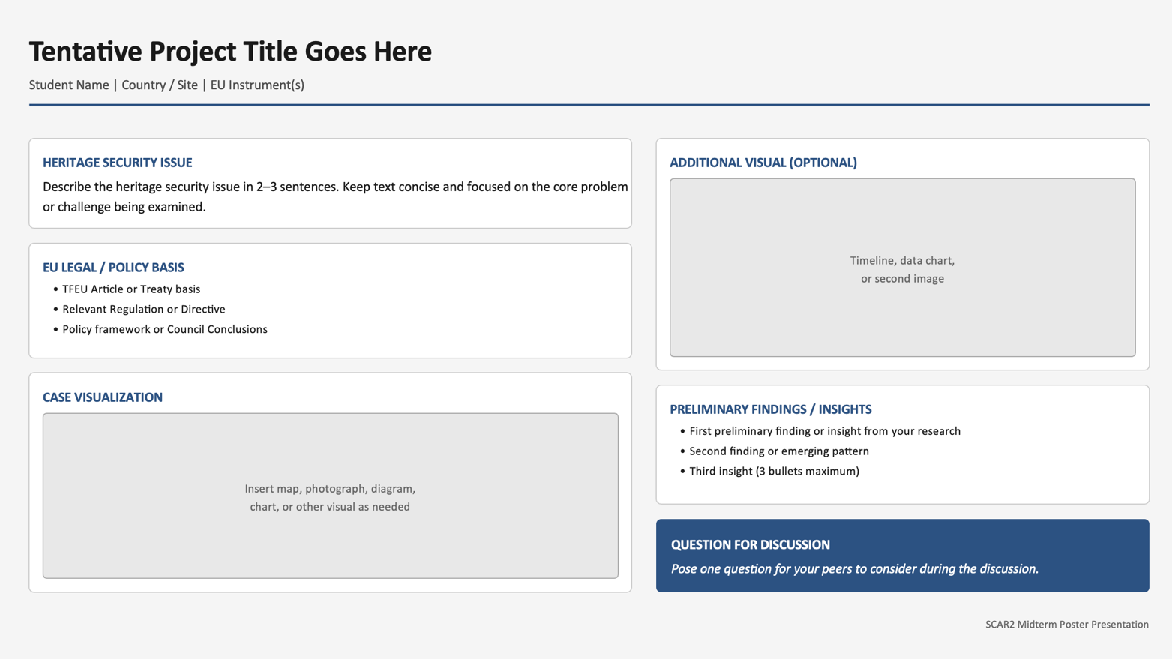

SLIDE STRUCTURE

Tentative Project Title
(Clear, specific, case-based)

Student Name | Country / Site | EU Instrument(s)
(e.g. Creative Europe, Regulation (EU) 2019/880, EU Aid Programme for the Turkish Cypriot Community, etc.)

1. Heritage Security Issue (2–3 sentences)

Briefly state:
- What heritage is at risk (tangible or intangible)
- Why it is vulnerable (conflict, under-funding, governance gaps, environmental risk, marginalization, illicit trade, etc.)
- Why this is a security issue, not just a cultural one

Example:
“This project examines how illicit trafficking of cultural goods entering the EU undermines cultural security by financing organized crime and eroding collective heritage. The case focuses on customs enforcement gaps revealed during Operation Pandora IX.”

2. EU Legal / Policy Basis (bullet points, concise)

Identify the formal EU entry point for the case:
- Treaty article, regulation, directive, or Council conclusion
- Relevant EU programme or funding instrument
- If applicable: relationship to national implementation

Example:
- Regulation (EU) 2019/880 (import of cultural goods)
- Implementing Regulation (EU) 2021/1079
- EU Strategy against Illicit Trafficking of Cultural Goods

3. Case Visualization (as needed)

Include 1-2 strong visual(s) as needed (not many):
- Map (site location, border, buffer zone, trade route)
- Diagram (institutional flow: EU → national → local)
- Photograph (site, damage, practice, archive)
- Simple chart (funding distribution, risk factors)

Rule: The visual must support analysis, not decorate.

4. Preliminary Findings / Insights (3 bullets max)

What are you beginning to see?
- Institutional strengths or gaps
- Tensions between EU values and EU tools
- Financing mismatches or governance constraints
- Early patterns—not final conclusions

Example:
- EU funding enables cooperation but avoids sovereignty questions
- Heritage financing favors scalable projects over local practices
- Enforcement effectiveness varies by Member State capacity

Question for Discussion (1 sentence)

Pose one focused question to invite feedback.

Example:
“Does the EU’s current funding architecture adequately support small-scale, place-based heritage under security pressure?”

_________________________________________

DESIGN GUIDELINES (IMPORTANT)

- Font: simple and readable (Calibri, Arial, Source Sans)
- Text: no paragraphs longer than 3 lines
- Color: neutral background; high contrast
- Images: properly credited if required
- No citations on the slide → mention sources orally if asked

HOW IT FITS THE 5’ PRESENTATION

- 1 min: title + heritage security issue
- 1 min: EU legal / policy framework
- 1–2 min: walk through the visual
- 1 min: preliminary findings
- Final sentence: discussion question

