How is whisky made?
The principals for the distillation of whisky have changed little over the last 200 years. Just three basic ingredients are needed - water, barley and yeast. Technology now aids production, but traditionally there are five stages to the process - malting, mashing, fermentation, distillation and maturation. Here we go through and expalin each of these important stages.

Step 1 – Malting
Barley contains starch and it is this starch which needs to be converted into soluble sugars to make alcohol. For this to occur, the barley must undergo germination and this first part of the prodess is called ‘malting’. Each distiller has their own preference about the type of barley they buy, but they need a type that produce high yields of soluble sugar. The barley is soaked for 2-3 days in warm water and then traditionally spread on the floor of a building called a malting house. It is turned regularly to maintain a constant temperature. This is also carried out on a commercial scale in large drums which rotate.

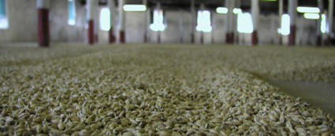

The malting floor at Springbank

When the barley has started to shoot, the germination has to be stopped by drying it in a kiln. Traditionally peat is used to power the kiln and it is at this point where the type of peat used and length of drying in the peat smoke can influence the flavour of the final spirit. The barley is now called ‘malt’ and this is ground down in a mill, with any husks and other debris being removed.

Step 2 – Mashing
The ground down malt, which is called ‘grist’, is now added to warm water to begin the extraction of the soluble sugars. The water is normally from a pure, reliable, local source - this is why most distilleries around the world are next to a river or lake. The character of this water can influence the final spirit as it can contain minerals from passing over or though granite, peat or other rock. The liquid combination of malt and water is called the ‘mash’. It is put into a large vessel called a mash tun and stirred for several hours.
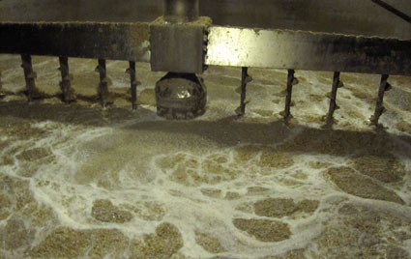

Inside the mash tun at Glen Moray

During this process, the sugars in the malt dissolve and these are drawn off through the bottom of the mash tun. The resulting liquid is called ‘wort’. This process is normally carried out three times with the water temperature being increased each time to extract the maximum amount of sugar. Only wort from the first two times is used. The third lot is put back into the next batch of new grist. Any residue, such as husks, is called ‘draff’. This is collected and used in the production of farm feed.

Step 3 – Fermentation
The wort is cooled and passed into large tanks called washbacks. These are traditionally made of wood, but now a number of distilleries use stainless steel. Here the yeast is added and the fermentation begins. The yeast turns the sugars that are present into alcohol. As with the barley and water, the distiller will carefully select the strain of yeast that they use and it can also have a small effect on the final flavour of the spirit. The fermentation normally takes around 48 hours to run its natural course, although some distilleries will let it go for longer so as to create further characteristics that they require. The liquid at this stage is called ‘wash’ and is low in alcohol strength (between 5-10% ABV), like beer or ale. You could make beer from the liquid at this point, but the difference with whisky is that the liquid is now distilled rather than brewed.

Step 4 – Distillation
In Scotland, the wash is traditionally distilled twice. In Ireland, it is distilled three times although there are exceptions in both countries. Here is a brief explanation of the double distillation process. The stills are made from copper, which has been found to be the best material for extracting impurities from the spirit as it is being distilled, and consist of a bowl shape at the bottom that rises up to the neck at the top. All are the same in principal, but a different shape will give a different flavour and character to the final spirit. Taller stills with longer necks will give finer, lighter spirits while shorter, fatter stills will produce a fuller, richer spirit.
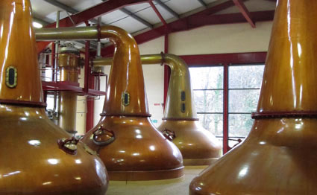

The stills at Glenburgie

The stills tend to work in pairs. Firstly, the wash enters the larger wash still and is heated (this was traditionally by coal, but is now largely by gas or steam). The liquid vaporises and rises up the still until it reaches the neck, where it condenses. This liquid is called ‘low wines’ and is unusable as it is. The low wines are passed to the second smaller still, called the spirit still. Any residue from the wash still is collected and used to manufacture farm feed. In the spirit still, the alcohol produced is split into three.

Alcohols from the beginning of the distillation (called ‘foreshots’) are very high in alcohol level and very pungent. Alcohols from the end (called ‘feints’) are weak but also pungent. It is only the alcohol from the middle or ‘heart’ of the distillation that is used and this is skillfully removed by a stillman and collected through the spirit safe. The foreshots and feints are then mixed with the next batch of low wines and re-distilled. The heart is the spirit that is then taken to be matured and that will become whisky. This ‘heart’ has an alcoholic strength of 65-70% ABV.

Step 5 – Maturation
The spirit is put into oak casks and stored. The most common types of oak casks are those that have previously been used in the American bourbon and Spanish sherry industries. The spirit must mature in casks for a minimum of three years before it is legally allowed to be called whisky in Scotland. During maturation, the flavours of the spirit combine with natural compounds in the wood cask and this gives the whisky its own characteristic flavour and aroma.
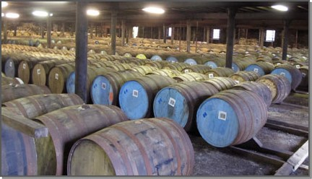

Casks maturing in Warehouse No.1 at Glenlivet

Wood is porous, so over time it will breathe in air from the surrounding environment in which it is stored. This will also give the whisky some unique characteristics. If the distillery storage facilities are next to the sea, on an island or in the middle of the Highlands then the air quality, temperature and humidity will be different and influence the end product. During each year of maturation about 2% of the spirit is lost through natural evaporation. This is called the ‘angel’s share’ and explains why older whiskies are less readily available and more expensive to buy. There is simply less whisky in the cask to bottle.

Πηγή: http://www.whiskyforeveryone.com/whisky_basics/how_is_whisky_made.html

