# English Cuisine

The cuisine of England has been shaped by the country’s temperate climate, its island geography and its history.

Traditional meals have ancient origins, such as bread and cheese, roasted and stewed meat, meat and game pies and freshwater and saltwater fish. The Forme of Cury is a 14th century English cookbook which contains recipes dating back to the royal court of Richard II. Customary dishes, such as fish and chips which were once eaten from newspaper with salt and malt vinegar, and pies and sausages with mashed potatoes, onions and gravy. These are now matched in popularity by curries from India and Bangladesh, stir-fries based on Chinese and Thai cooking as well as French and Italian dishes. The British have also adopted the innovation of fast food from the United States.

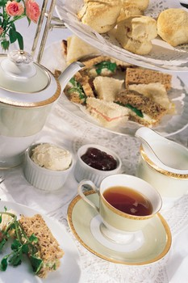

The Sunday roast is one of the most common features of English cooking. This traditional Sunday dinner consists of roast beef, lamb or a roast chicken accompanied by roast potatoes, roasted vegetables served with gravy and Yorkshire pudding. The most popular Christmas roast now is turkey which has surpassed the goose of Dicken’s time.

England is internationally famous for its fish and chips widely available in restaurants and take-away shops. Traditionally fish and chips are served with a side order of mushy peas with salt and malt vinegar as condiments. Such food as scampi, a deep fried breaded prawn dish and fish cakes are also offered. Indian and Chinese food has grown in popularity and there are now also kebab houses, pizza restaurants and American-style fried chicken restaurants.

It is believed that everything in England stops for tea time in the mid-afternoon. At tea time the meal usually consists of things like scones with jam and butter or clotted cream, butterfly cakes (small simple sponge cakes with or without icing), biscuits and sandwiches. The tea itself is served with lemon or milk. However now the tradition of tea time has been replaced by snacking or at times simply ignored.

Cheese is generally hard and made from cow’s milk. The most common type is cheddar cheese which was originally made in the town of Cheddar. Other cheeses are: Tangy Cheshire a dense, crumbly cheese produced in the English county of Cheshire and four neighbouring counties. It comes in three varieties: red, white and blue. The majority of production is the original plain white version, the red is coloured with annatto to make it a deep orange shade and was developed in the hills of North Wales and the blue has blue veins. Salty Caerphilly a hard, white cheese that originated in an area around the town of Caerphilly in Wales but is also made in England now, particularly in the South West and on the English border, with Wales. It is light in colour and crumbly. Sage Derby a mild, mottled green, semi-hard cheese with a sage flavour. The colour is from sage leaves. Red Leicester a crumbly cheese also coloured orange by annatto extract. Its mild flavour goes well with most food and wine or beer and is good for making Welsh rarebit. Double Glouchester a traditional English cheddar-style cheese from Gloucestershire with a bold orange color and bright, eggy, and somewhat sharp flavour. Wensleydale white Wensleydale cheese has a mild, slightly sweet flavour with a honey aftertaste, whereas blue Wensleydale is robust in flavour. Stilton is produced in two varieties: the well-known blue and the lesser-known white. Both have been granted the status of a protected designation of origin by the European Commission. Only cheese produced in the three counties of Derbyshire, Leicestershire, and Nottinghamshire—and made according to a strict code–may be called "Stilton".

**Typical English dishes:**

**Bangers and mash** or sausages and mash is an English/Irish dish made of mashed potatoes and sausages. The sausages may be a variety of flavoured sausage made of pork or beef with apple or tomato seasoning or a Cumberland sausage. This dish is usually served with a rich, onion gravy.

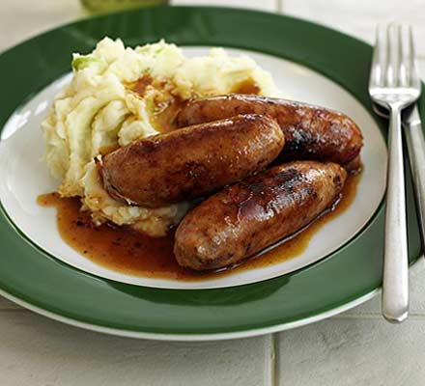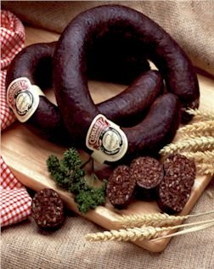

**Black pudding** is an English term for sausage made by cooking blood with a filler until it’s thick enough to congeal when cooled. Pig or cattle blood is most often used. Typical fillers include meat, fat, suet, bread, sweet potato, barley and oatmeal.

**Bubble and Squeak** (at times just called bubble) is a traditional English dish made with the leftover vegetables from a roast dinner. The main ingredients are potatoes and cabbage but other vegetables such as carrots, peas, brussels sprouts can be added. Usually it is served with cold meat left over from the Sunday roast and pickles. The chopped vegetables and meat are pan fried together with mashed potato until the mixture is well-cooked and brown on both sides. Prepared frozen and tinned versions are available.

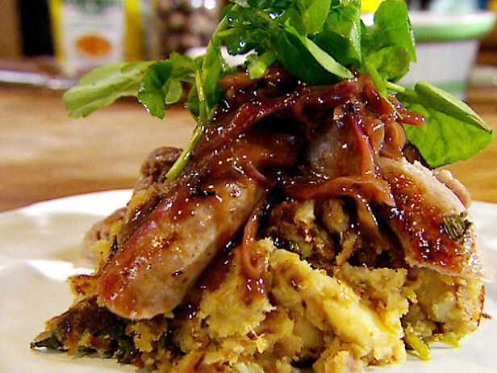

**Cauliflower cheese** a British dish usually eaten as a main course for lunch or dinner. It consists of lightly boiled pieces of cauliflower covered with a milk-based cheese sauce, a strong, hard cheese (such as cheddar) is preferred. Another sauce which may be used is a Bechamel sauce flavored with cheese, English mustard and nutmeg. The dish is topped with grated cheese (sometimes mixed with bread crumbs) and lightly grilled to finish it. Some extra ingredients such as pasta or tuna may be added to make it a main meal.

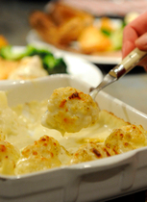

**Cottage pie** also known as Shepherd’s pie which is a meat pie with a crust made of mashed potatoes. It has been around since 1791 when the potato was being introduced as an edible crop affordable for the poor. In early cookbooks the dish was made with leftover roasted meat of any kind and the pie dish was also lined with mashed potato as well as having a mashed potato crust on top. The term Shepherd’s pie appeared in the 1870s.

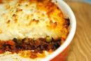

**Cumberland sausages** are a type of traditional sausage that originated in the ancient county of Cumberland. Usually they are very long (up to 50cm) and sold rolled in a flat circular coil. The meat is pork and seasonings made up of a variety of spices and herbs. Commonly it is dominated by pepper, both black and white. Traditionally no colouring or preservatives are added. The meat in the sausage must be chopped not minced so that the texture is chunky. Usually served with fried egg along with chips and peas.

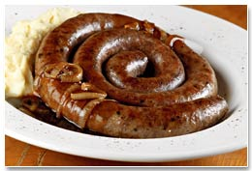

**Faggot** a kind of meatball, a traditional dish in the UK especially in the Midlands of England. Made from meat off-cuts and offal (innards), especially pork. Usually made from pig heart, liver and fatty belly meat or bacon minced together, with herbs added for flavouring and sometimes breadcrumbs. Then the mixture is shaped into balls, wrapped round with caul fat (from the pigs abdomen) and baked.

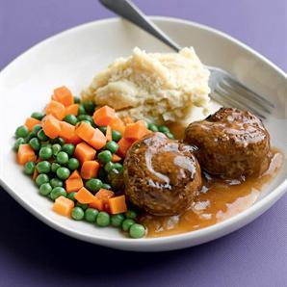

**Hash** is often a mixture of beef (often leftovers of corned beef or roast beef), onions, potatoes and spices that are mashed together into a coarse, chunky paste and then cooked, alone or with other ingredients.

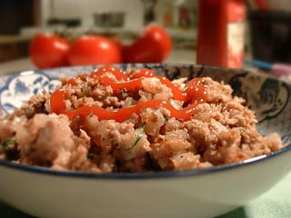

**Pie and mash** is a traditional London working class food. This is a minced beef pie and mashed potato. It’s common for the mashed potato to be spread around one side of the plate and for a type of parsley sauce called liquor (non-alcoholic) to be added. The sauce is traditionally made using water kept from preparation of stewed eels. Often served in eel and pie houses.

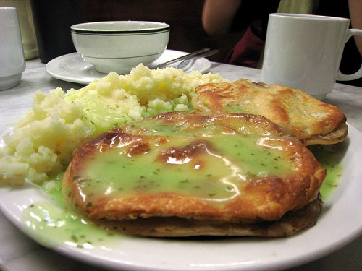

**Ploughman’s lunch** is a cold snack or meal usually consisting of a thick piece of cheese, relish, chunk of bread and butter. It is often accompanied by a green salad, while other common additions are half an apple, celery, pate, crisps, diced hard boiled egg or beet root. A common menu item in English pubs.

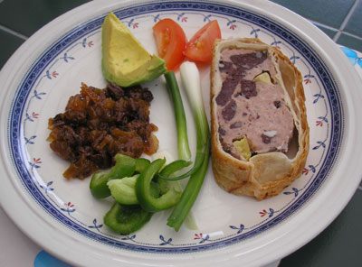

**Toad in the hole** is a traditional English dish which is made up of sausages in Yorkshire pudding batter, usually served with vegetables and gravy.

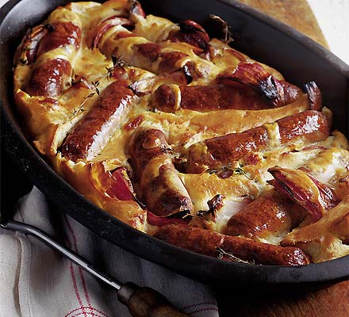

**Cornish Pasty - Cornish Pasty Recipe**

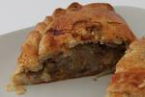

Prep Time: 25 minutes

Cook Time: 45 minutes

**Ingredients:**

*For the Pastry*

• 4 oz/125g all purpose/plain flour

• Pinch of salt

• 2oz/ 55g butter, cubed

• 2-3 tbsp cold water

*For the Filling*

• ¼ cup/50g onion, finely chopped

• ½ cup /110g potato, cut into 1/4 inch /5 mm dice

• 4oz /110g rump steak, cut into small cubes

• Salt and pepper

• 1 egg, lightly beaten

**Preparation:**

**Makes 2 pasties**

Pre-heat oven to 425 °F /220 °C/ Gas 7.

• Place the flour, butter and salt into a large clean bowl.

• Rub the butter into the flour with your fingertips until the mixture resembles fine breadcrumbs, working as quickly as possible to prevent the dough becoming warm.

• Add the water to the mixture and using a cold knife stir until the dough binds together, add more cold water a teaspoon at a time if the mixture is too dry,

• Wrap the dough in Saran wrap/Clingfilm and chill for a minimum of 15 minutes, up to 30 minutes.

The dough can also be made in a food processor by mixing the flour, butter and salt in the bowl of the processor on a pulse setting. When the mixture resembles breadcrumbs, add the water, slowly, through the funnel until the dough comes together in a ball. Wrap in Saran wrap/ Clingfilm and chill as above.

• Divide the pastry into 4 and roll each piece into rounds the size of a tea plate (approx 6 - 7 inches).

• Place the onion, potato and meat into a large mixing bowl and mix thoroughly. Season well with salt and pepper.

• Divide the meat mixture between each pastry circle. Brush the edges with a little beaten egg.

• Draw up the edges of the pastry into a line above the centre of the filling. Crimp the top edge ensuring the seal is tight. Brush each pasty all over with the remaining beaten egg.

• Place the pasties on a greased baking sheet and bake for 45 minutes until golden brown.

• Serve hot or cold.

**Cottage Pie - Easy Cottage Pie Recipe**

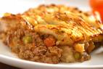

Prep Time: 30 minutes

Cook Time: 40 minutes

**Ingredients:**

• 2 lb / 900g peeled potatoes, quartered

• 6 tbsp milk

• 1 stick/ 110g butter, cubed + 1 tbsp for the sauce

• Salt and ground black pepper

• 1/2 tbsp lard or dripping

• 1 cup/ 115g chopped onion

• 1 cup / 115g chopped carrot

• 1 clove garlic, minced

• 2 cups / 450g ground/ minced beef

• 1 pint / 600 ml beef stock

• 1 cup / 115g chopped white mushrooms

• 2 tbsp finely chopped flat leaf parsley

• 1 tbsp all-purpose flour

• 1 cup/ 115g grated Cheddar Cheese

**Preparation:**

**Serves 6**

• Heat the oven to 375°F/190°C/Gas 5

• Boil the potatoes until soft, drain. Place the milk and butter in the pan used to boil the potatoes, return to the heat and warm gently until the butter has melted. Add the potatoes and mash. Season to taste and keep to one side.

• Melt the lard or dripping in a large deep pan. Add the onion and carrot and fry for 5 minutes. Add the garlic and cook for another minute.

• Add the ground beef and one-third of the beef stock to the onion and carrot mixture and cook, stirring constantly until all the meat is browned. Add the remaining stock, parsley and mushrooms, season with salt and pepper. Cover with a lid and cook for 15 minutes.

• Mash the flour into the remaining 1 tbsp butter then add in small pieces to the ground meat sauce, stirring until all the flour has dissolved and the sauce has thickened slightly, approx 5 mins.

• Place the meat sauce into an 8"/ 20cm by 3"/7cm deep ceramic of glass ovenproof dish and cover with the mashed potato. Sprinkle the grated cheese potato on top and bake in the heated oven for 30 - 35 mins until the surface is crisp and browned. Serve immediately

**Traditional Lancashire hotpot**

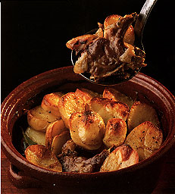

**Ingredients**

• 900g/2lb best end and middle neck British lamb, sliced into chops

• 1 tbsp groundnut oil

• Butter

• 4 lamb's kidneys, skinned, cored and cut into bite-sized pieces

• 3 onions, sliced into 1cm/½in wedges

• 1 tbsp plain flour

• 570ml/20fl oz freshly boiled water

• ½ tsp Worcestershire sauce

• 1 fresh bay leaf

• 2 thyme sprigs

• 900g/2lb potatoes, cut into 2cm slices

• sea salt

• freshly ground black pepper

**Method**

**Serves 4**

• Pre-heat the oven to 170C/325F/Gas 3.

• Trim the lamb of any excess fat and pat dry with paper towel.

• Heat the oil and a small knob of butter in a large heavy-based frying pan until very hot. Add the lamb, two or three pieces at a time, and fry until brown, turning once. Once browned, put them in a wide 3.5-litre casserole. Brown the pieces of kidney.

• Once the meat and kidney are in the casserole, add the onions to the pan. Fry over medium heat, adding a little more butter to the pan if necessary, for about ten minutes until browned at the edges.

• Stir in the flour then gradually add the hot water and Worcestershire sauce, stirring until the flour and liquid are smoothly blended. Season with salt and pepper and bring to simmering point. Pour over the meat in the casserole.

• Add the bay leaf and thyme, then arrange the potato slices on top in an overlapping pattern. Season the potatoes and dot the surface with a few dabs of butter.

• Cover with a tight-fitting lid and put in the oven. Cook for 1 hour 30 minutes. Towards the end of cooking time, remove the lid and brush the potatoes with a little more butter. Then place under the grill to crisp up. Alternatively, remove the lid and increase the heat to 200C/400F/Gas 6 for the last 15 minutes of cooking.

• Remove the bay leaf and thyme before serving.

**ΜΕΤΑΦΡΑΣΤΙΚΕΣ ΟΔΗΓΙΕΣ**

Το μετάφρασμα θεωρούμε ότι θα δημοσιευτεί σε μια ελληνική ιστοσελίδα όπως η: <https://caruso.gr/>.

Οι αναγνώστες του μεταφράσματος είναι είτε άτομα που ενδιαφέρονται για την κουζίνα και τη μαγειρική είτε επαγγελματίες σεφ.

Επισκεφθείτε τις σελίδες τους συνδέσμους των οποίων θα βρείτε στην κατηγορία «Σύνδεσμοι» σε δύο υποφακέλους («ENGLISH CUISINE – ΠΑΡΑΛΛΗΛΕΣ ΠΗΓΕΣ» και «ΣΥΝΤΑΓΕΣ – ΠΑΡΑΛΛΗΛΑ ΚΕΙΜΕΝΑ») προκειμένου να εντοπίσετε ορολογία και κειμενοτυπολογικές συμβάσεις.