΄Αδειες Χρήσης

- Το παρόν εκπαιδευτικό υλικό υπόκειται σε άδειες χρήσης Creative Commons.
- Για εκπαιδευτικό υλικό, όπως εικόνες, που υπόκειται σε άλλου τύπου άδειας χρήσης, η άδεια χρήσης αναφέρεται ρητώς.

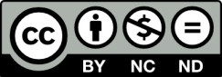

Χρηματοδότηση

- Το παρόν εκπαιδευτικό υλικό έχει αναπτυχθεί στα πλαίσια του εκπαιδευτικού έργου του διδάσκοντα.
- Το έργο «Ανοικτά Ακαδημαϊκά Μαθήματα στο Πανεπιστήμιο Αθηνών»
έχει χρηματοδοτήσει μόνο τη αναδιαμόρφωση του εκπαιδευτικού υλικού.

- Το έργο υλοποιείται στο πλαίσιο του Επιχειρησιακού Προγράμματος «Εκπαίδευση και Δια Βίου Μάθηση» και συγχρηματοδοτείται από την Ευρωπαϊκή ΄Ενωση (Ευρωπαϊκό Κοινωνικό Ταμείο) και από εθνικούς πόρους.

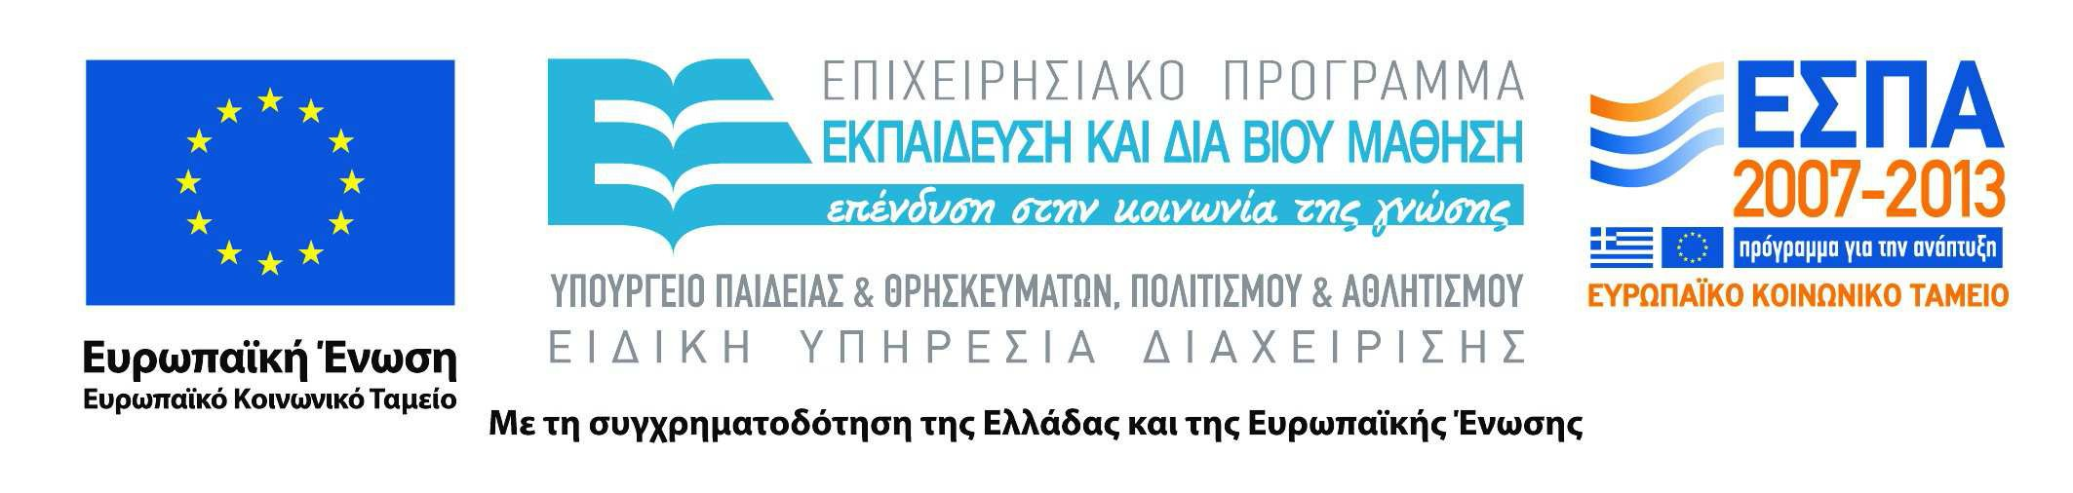

DLM Forum '96
Electronic Records - Co-operation Europe-Wide
[Home page]
COUNCIL OF THE EUROPEAN UNION
CONCLUSIONS of 17 June 1994
concerning greater cooperation in the field of archives (94/C 235/03)
The Council considers that archives constitute a significant part of the cultural heritage of European significance referred to in Article 128 of the Treaty establishing the European Community. The exploitation of archives can contribute to achieving the aim, also provided for in Article 128, of improvement of the knowledge of the culture and history of the European peoples.
It notes with interest the report on archives forwarded by the Commission and prepared by a group of experts further to its resolution of 14 November 1991 on arrangements concerning archives. Further to that report, it agrees on the importance of greater cooperation between the Member States and at Community level in the field of archives.
The Council calls upon the Commission to include archives in the communication which it has undertaken to make on the Community's cultural heritage and notes with interest among the actions contemplated in the report those relating to the following points:
- organizing a multidisciplinary forum to be held in the framework of the Community on the problems of the management, storage, conservation and retrieval of machine-readable data, inviting public administrations and national archives services, as well as representatives of industry and of research, to take part in the forum,
- stimulating, in conjunction with the Member States, exchanges of students and archivists via Community action programmes in the field of education and vocational training, or by other means,
- preparing and encouraging the publication in all the official languages of the Community of a practical guide to the procedures and other provisions in force in the Member States and in the Institutions for user-access to their archives,
- preparing and encouraging the publication of appropriate technical publications intended to disseminate research carried out and any research findings concerning the preservation and restoration of archives documents and material,
- using different technologies, encourage the publication of information with regard to archives material.
The Commission could obtain the technical assistance of the Member States in examining these points and use the expertise existing in non-governmental organizations such as the International Council on Archives.

